






Communicate on the telephone
D1.HRS.CL1.04
D1.HOT.CL1.07
D2.TCC.CL1.05
Trainer Guide

Communicate on the telephone

D1.HRS.CL1.04
D1.HOT.CL1.07
D2.TCC.CL1.05

Trainer Guide





Project Base
William Angliss Institute of TAFE
555 La Trobe Street
Melbourne 3000 Victoria
Telephone: | (03) 9606 2111
Facsimile: | (03) 9670 1330
Acknowledgements
Project Director: | Wayne Crosbie
Chief Writer: | Alan Hickman
Subject Writer: | Alan Hickman
Project Manager/Editor: | Alan Maguire
DTP/Production | Daniel Chee, Mai Vu, Jirayu Thangcharoensamut, Kaly Quach

The Association of Southeast Asian Nations (ASEAN) was established on 8 August 1967. The Member States of the Association are Brunei Darussalam, Cambodia, Indonesia, Lao PDR, Malaysia, Myanmar, Philippines, Singapore, Thailand and Viet Nam.
The ASEAN Secretariat is based in Jakarta, Indonesia.
General Information on ASEAN appears online at the ASEAN Website: www.asean.org.
All text is produced by William Angliss Institute of TAFE for the ASEAN Project on “Toolbox Development for Priority Tourism Labour Division”.
This publication is supported by the Australian Government’s aid program through the ASEAN-Australia Development Cooperation Program Phase II (AADCP II).
Copyright: Association of Southeast Asian Nations (ASEAN) 2012.
All rights reserved.
Disclaimer
Every effort has been made to ensure that this publication is free from errors or omissions. However, you should conduct your own enquiries and seek professional advice before relying on any fact, statement or matter contained in this book. The ASEAN Secretariat and William Angliss Institute of TAFE are not responsible for any injury, loss or damage as a result of material included or omitted from this course. Information in this module is current at the time of publication. Time of publication is indicated in the date stamp at the bottom of each page.
Some images appearing in this resource have been purchased from stock photography suppliers Shutterstock and iStockphoto and other third party copyright owners and as such are non-transferable and non-exclusive. Clip arts, font images and illustrations used are from the Microsoft Office Clip Art and Media Library. Some images have been provided by and are the property of William Angliss Institute.
Additional images have been sourced from Flickr and SXC and are used under Creative Commons licence: http://creativecommons.org/licenses/by/2.0/deed.en

File name: TG _Communicate_on_the_telephone_refined





Table of contents
Competency Based Training (CBT) and assessment an introduction for trainers 1
Competency standard 11
Notes and PowerPoint slides 17
Recommended training equipment 89
Instructions for Trainers for using PowerPoint – Presenter View 91
Appendix – ASEAN acronyms 93

Competency Based Training (CBT) and assessment an introduction for trainers

Competency
Competency refers to the ability to perform particular tasks and duties to the standard of performance expected in the workplace.
Competency requires the application of specified knowledge, skills and attitudes relevant to effective participation, consistently over time and in the workplace environment.
The essential skills and knowledge are either identified separately or combined.
Knowledge identifies what a person needs to know to perform the work in an informed and effective manner.
Skills describe the application of knowledge to situations where understanding is converted into a workplace outcome.
Attitude describes the founding reasons behind the need for certain knowledge or why skills are performed in a specified manner.
Competency covers all aspects of workplace performance and involves:
- Performing individual tasks
- Managing a range of different tasks
- Responding to contingencies or breakdowns
- Dealing with the responsibilities of the workplace
- Working with others.

Unit of Competency
Like with any training qualification or program, a range of subject topics are identified that focus on the ability in a certain work area, responsibility or function.
Each manual focuses on a specific unit of competency that applies in the hospitality workplace.
In this manual a unit of competency is identified as a ‘unit’.
Each unit of competency identifies a discrete workplace requirement and includes:
- Knowledge and skills that underpin competency
- Language, literacy and numeracy
- Occupational safety and health requirements.
Each unit of competency must be adhered to in training and assessment to ensure consistency of outcomes.

Element of Competency
An element of competency describes the essential outcomes within a unit of competency.
The elements of competency are the basic building blocks of the unit of competency. They describe in terms of outcomes the significant functions and tasks that make up the competency.
In this manual elements of competency are identified as an ‘element’.

Performance criteria
Performance criteria indicate the standard of performance that is required to demonstrate achievement within an element of competency. The standards reflect identified industry skill needs.
Performance criteria will be made up of certain specified skills, knowledge and attitudes.

Learning
For the purpose of this manual learning incorporates two key activities:
- Training
- Assessment.
Both of these activities will be discussed in detail in this introduction.
Today training and assessment can be delivered in a variety of ways. It may be provided to participants:
- On-the-job – in the workplace
- Off-the-job – at an educational institution or dedicated training environment
- As a combination of these two options.
No longer is it necessary for learners to be absent from the workplace for long periods of time in order to obtain recognised and accredited qualifications.

Learning Approaches
This manual will identify two avenues to facilitate learning:
Competency Based Training (CBT)
This is the strategy of developing a participant’s competency.
Educational institutions utilise a range of training strategies to ensure that participants are able to gain the knowledge and skills required for successful:
- Completion of the training program or qualification
- Implementation in the workplace.
The strategies selected should be chosen based on suitability and the learning styles of participants.

Competency Based Assessment (CBA)
This is the strategy of assessing competency of a participant.
Educational institutions utilise a range of assessment strategies to ensure that participants are assessed in a manner that demonstrates validity, fairness, reliability, flexibility and fairness of assessment processes.

Flexibility in Learning
It is important to note that flexibility in training and assessment strategies is required to meet the needs of participants who may have learning difficulties. The strategies used will vary, taking into account the needs of individual participants with learning difficulties. However they will be applied in a manner which does not discriminate against the participant or the participant body as a whole.
Catering for Participant Diversity
Participants have diverse backgrounds, needs and interests. When planning training and assessment activities to cater for individual differences, trainers and assessors should:
- Consider individuals’ experiences, learning styles and interests
- Develop questions and activities that are aimed at different levels of ability
- Modify the expectations for some participants
- Provide opportunities for a variety of forms of participation, such as individual, pair and small group activities
- Assess participants based on individual progress and outcomes.
The diversity among participants also provides a good reason for building up a learning community in which participants support each other’s learning.
Participant Centred Learning
This involves taking into account structuring training and assessment that:
- Builds on strengths – Training environments need to demonstrate the many positive features of local participants (such as the attribution of academic success to effort, and the social nature of achievement motivation) and of their trainers (such as a strong emphasis on subject disciplines and moral responsibility). These strengths and uniqueness of local participants and trainers should be acknowledged and treasured
- Acknowledges prior knowledge and experience – The learning activities should be planned with participants’ prior knowledge and experience in mind
- Understands learning objectives – Each learning activity should have clear learning objectives and participants should be informed of them at the outset. Trainers should also be clear about the purpose of assignments and explain their significance to participants
- Teaches for understanding – The pedagogies chosen should aim at enabling participants to act and think flexibly with what they know
- Teaches for independent learning – Generic skills and reflection should be nurtured through learning activities in appropriate contexts of the curriculum. Participants should be encouraged to take responsibility for their own learning
- Enhances motivation – Learning is most effective when participants are motivated. Various strategies should be used to arouse the interest of participants
- Makes effective use of resources – A variety of teaching resources can be employed as tools for learning
- Maximises engagement – In conducting learning activities, it is important for the minds of participants to be actively engaged
- Aligns assessment with learning and teaching – Feedback and assessment should be an integral part of learning and teaching
- Caters for learner diversity – Trainers should be aware that participants have different characteristics and strengths and try to nurture these rather than impose a standard set of expectations.
Active Learning
The goal of nurturing independent learning in participants does not imply that they always have to work in isolation or solely in a classroom. On the contrary, the construction of knowledge in tourism and hospitality studies can often best be carried out in collaboration with others in the field. Sharing experiences, insights and views on issues of common concern, and working together to collect information through conducting investigative studies in the field (active learning) can contribute a lot to their eventual success.
Active learning has an important part to play in fostering a sense of community in the class. First, to operate successfully, a learning community requires an ethos of acceptance and a sense of trust among participants, and between them and their trainers. Trainers can help to foster acceptance and trust through encouragement and personal example, and by allowing participants to take risks as they explore and articulate their views, however immature these may appear to be. Participants also come to realise that their classmates (and their trainers) are partners in learning and solving.
Trainers can also encourage cooperative learning by designing appropriate group learning tasks, which include, for example, collecting background information, conducting small-scale surveys, or producing media presentations on certain issues and themes. Participants need to be reminded that, while they should work towards successful completion of the field tasks, developing positive peer relationships in the process is an important objective of all group work.

Competency Based Training (CBT)
Principle of Competency Based Training
Competency based training is aimed at developing the knowledge, skills and attitudes of participants, through a variety of training tools.
Training Strategies
The aims of this curriculum are to enable participants to:
- Undertake a variety of subject courses that are relevant to industry in the current environment
- Learn current industry skills, information and trends relevant to industry
- Learn through a range of practical and theoretical approaches
- Be able to identify, explore and solve issues in a productive manner
- Be able to become confident, equipped and flexible managers of the future
- Be ‘job ready’ and a valuable employee in the industry upon graduation of any qualification level.
To ensure participants are able to gain the knowledge and skills required to meet competency in each unit of competency in the qualification, a range of training delivery modes are used.
Types of Training
In choosing learning and teaching strategies, trainers should take into account the practical, complex and multi-disciplinary nature of the subject area, as well as their participant’s prior knowledge, learning styles and abilities.
Training outcomes can be attained by utilising one or more delivery methods:
Lecture/Tutorial
This is a common method of training involving transfer of information from the trainer to the participants. It is an effective approach to introduce new concepts or information to the learners and also to build upon the existing knowledge. The listener is expected to reflect on the subject and seek clarifications on the doubts.
Demonstration
Demonstration is a very effective training method that involves a trainer showing a participant how to perform a task or activity. Through a visual demonstration, trainers may also explain reasoning behind certain actions or provide supplementary information to help facilitate understanding.
Group Discussions
Brainstorming in which all the members in a group express their ideas, views and opinions on a given topic, is a free flow and exchange of knowledge among the participants and the trainer. The discussion is carried out by the group on the basis of their own experience, perceptions and values. This will facilitate acquiring new knowledge. When everybody is expected to participate in the group discussion, even the introverted persons will also get stimulated and try to articulate their feelings.
The ideas that emerge in the discussions should be noted down and presentations are to be made by the groups. Sometimes consensus needs to be arrived at on a given topic. Group discussions are to be held under the moderation of a leader guided by the trainer. Group discussion technique triggers thinking process, encourages interactions and enhances communication skills.
Role Play
This is a common and very effective method of bringing into the classroom real life situations, which may not otherwise be possible. Participants are made to enact a particular role so as to give a real feel of the roles they may be called upon to play. This enables participants to understand the behaviour of others as well as their own emotions and feelings. The instructor must brief the role players on what is expected of them. The role player may either be given a ready-made script, which they can memorise and enact, or they may be required to develop their own scripts around a given situation. This technique is extremely useful in understanding creative selling techniques and human relations. It can be entertaining and energising and it helps the reserved and less literate to express their feelings.

Simulation Games
When trainees need to become aware of something that they have not been conscious of, simulations can be a useful mechanism. Simulation games are a method based on "here and now" experience shared by all the participants. The games focus on the participation of the trainees and their willingness to share their ideas with others. A "near real life" situation is created providing an opportunity to which they apply themselves by adopting certain behaviour. They then experience the impact of their behaviour on the situation. It is carried out to generate responses and reactions based on the real feelings of the participants, which are subsequently analysed by the trainer.
While use of simulation games can result in very effective learning, it needs considerable trainer competence to analyse the situations.
Individual /Group Exercises
Exercises are often introduced to find out how much the participant has assimilated. This method involves imparting instructions to participants on a particular subject through use of written exercises. In the group exercises, the entire class is divided into small groups, and members are asked to collaborate to arrive at a consensus or solution to a problem.
Case Study
This is a training method that enables the trainer and the participant to experience a real life situation. It may be on account of events in the past or situations in the present, in which there may be one or more problems to be solved and decisions to be taken. The basic objective of a case study is to help participants diagnose, analyse and/or solve a particular problem and to make them internalise the critical inputs delivered in the training. Questions are generally given at the end of the case study to direct the participants and to stimulate their thinking towards possible solutions. Studies may be presented in written or verbal form.
Field Visit
This involves a carefully planned visit or tour to a place of learning or interest. The idea is to give first-hand knowledge by personal observation of field situations, and to relate theory with practice. The emphasis is on observing, exploring, asking questions and understanding. The trainer should remember to brief the participants about what they should observe and about the customs and norms that need to be respected.
Group Presentation
The participants are asked to work in groups and produce the results and findings of their group work to the members of another sub-group. By this method participants get a good picture of each other's views and perceptions on the topic and they are able to compare them with their own point of view. The pooling and sharing of findings enriches the discussion and learning process.
Practice Sessions
This method is of paramount importance for skills training. Participants are provided with an opportunity to practice in a controlled situation what they have learnt. It could be real life or through a make-believe situation.

Games
This is a group process and includes those methods that involve usually fun-based activity, aimed at conveying feelings and experiences, which are everyday in nature, and applying them within the game being played. A game has set rules and regulations, and may or may not include a competitive element. After the game is played, it is essential that the participants be debriefed and their lessons and experiences consolidated by the trainer.
Research
Trainers may require learners to undertake research activities, including online research, to gather information or further understanding about a specific subject area.

Competency Based Assessment (CBA)
Principle of Competency Based Assessment
Competency based assessment is aimed at compiling a list of evidence that shows that a person is competent in a particular unit of competency.
Competencies are gained through a multitude of ways including:
- Training and development programs
- Formal education
- Life experience
- Apprenticeships
- On-the-job experience
- Self-help programs.
All of these together contribute to job competence in a person. Ultimately, assessors and participants work together, through the ‘collection of evidence’ in determining overall competence.
This evidence can be collected:
- Using different formats
- Using different people
- Collected over a period of time.
The assessor, who is ideally someone with considerable experience in the area being assessed, reviews the evidence and verifies the person as being competent or not.
Flexibility in Assessment
Whilst allocated assessment tools have been identified for this subject, all attempts are made to determine competency and suitable alternate assessment tools may be used, according to the requirements of the participant.
The assessment needs to be equitable for all participants, taking into account their cultural and linguistic needs.
Competency must be proven regardless of:
- Language
- Delivery Method
- Assessment Method.
Assessment Objectives
The assessment tools used for subjects are designed to determine competency against the ‘elements of competency’ and their associated ‘performance criteria’.
The assessment tools are used to identify sufficient:
- Knowledge, including underpinning knowledge
- Skills
- Attitudes
Assessment tools are activities that trainees are required to undertake to prove participant competency in this subject.
All assessments must be completed satisfactorily for participants to obtain competence in this subject. There are no exceptions to this requirement, however, it is possible that in some cases several assessment items may be combined and assessed together.
Types of Assessment
Allocated Assessment Tools
There are a number of assessment tools that are used to determine competency in this subject:
- Work projects
- Written questions
- Oral questions
- Third Party Report
- Observation Checklist.
Instructions on how assessors should conduct these assessment methods are explained in the Assessment Manuals.
Alternative Assessment Tools
Whilst this subject has identified assessment tools, as indicated above, this does not restrict the assessor from using different assessment methods to measure the competency of a participant.
Evidence is simply proof that the assessor gathers to show participants can actually do what they are required to do.
Whilst there is a distinct requirement for participants to demonstrate competency, there are many and diverse sources of evidence available to the assessor.
Ongoing performance at work, as verified by a supervisor or physical evidence, can count towards assessment. Additionally, the assessor can talk to customers or work colleagues to gather evidence about performance.
A range of assessment methods to assess competency include:
- Practical demonstrations
- Practical demonstrations in simulated work conditions
- Problem solving
- Portfolios of evidence
- Critical incident reports
- Journals
- Oral presentations
- Interviews
- Videos
- Visuals: slides, audio tapes
- Case studies
- Log books
- Projects
- Role plays
- Group projects
- Group discussions
- Examinations.
Recognition of Prior Learning
Recognition of Prior Learning is the process that gives current industry professionals who do not have a formal qualification, the opportunity to benchmark their extensive skills and experience against the standards set out in each unit of competency/subject.
Also known as a Skills Recognition Audit (SRA), this process is a learning and assessment pathway which encompasses:
- Recognition of Current Competencies (RCC)
- Skills auditing
- Gap analysis and training
- Credit transfer.
Assessing competency
As mentioned, assessment is the process of identifying a participant’s current knowledge, skills and attitudes sets against all elements of competency within a unit of competency. Traditionally in education, grades or marks were given to participants, dependent on how many questions the participant successfully answered in an assessment tool.
Competency based assessment does not award grades, but simply identifies if the participant has the knowledge, skills and attitudes to undertake the required task to the specified standard.
Therefore, when assessing competency, an assessor has two possible results that can be awarded:
- Pass Competent (PC)
- Not Yet Competent (NYC).
Pass Competent (PC)
If the participant is able to successfully answer or demonstrate what is required, to the expected standards of the performance criteria, they will be deemed as ‘Pass Competent’ (PC).
The assessor will award a ‘Pass Competent’ (PC) if they feel the participant has the necessary knowledge, skills and attitudes in all assessment tasks for a unit.
Not Yet Competent’ (NYC)
If the participant is unable to answer or demonstrate competency to the desired standard, they will be deemed to be ‘Not Yet Competent’ (NYC).
This does not mean the participant will need to complete all the assessment tasks again. The focus will be on the specific assessment tasks that were not performed to the expected standards.
The participant may be required to:
a) Undertake further training or instruction
b) Undertake the assessment task again until they are deemed to be ‘Pass Competent’.

Competency standard
UNIT TITLE: COMMUNICATE ON THE TELEPHONE |  |  |  | NOMINAL HOURS: 10
UNIT NUMBER: D1.HRS.CL1.04 D1.HOT.CL1.07 D2.TCC.CL1.05
UNIT DESCRIPTOR: This unit deals with the skills and knowledge required to communicate on the telephone in a range of settings within the hotel and travel industries workplace context
ELEMENTS AND PERFORMANCE CRITERIA | UNIT VARIABLE AND ASSESSMENT GUIDE
Element 1: Respond to incoming telephone calls  1.1 Answer calls promptly, in an appropriate manner in accordance with enterprise standards  1.2 Offer friendly assistance to the caller, and accurately establish the purpose of the call  1.3 Repeat call details to the caller to confirm understanding  1.4 Answer caller enquiries promptly, or transfer caller to the appropriate location/person  1.5 Record caller requests accurately and pass on to the appropriate department/person for follow-up  1.6 Relay messages accurately to the nominated person within designated timelines  1.7 Report threatening or suspicious phone calls promptly to the appropriate person, in accordance with enterprise procedures  1.8 Use language, tone and volume appropriate to phone calls | Unit Variables  The Unit Variables provide advice to interpret the scope and context of this unit of competence, allowing for differences between enterprises and workplaces. It relates to the unit as a whole and facilitates holistic assessment  This unit applies to communicating on the telephone within the labour divisions of the hotel and travel industries and may include:  - Front Office  - Housekeeping  - Food and Beverage Service  - Food Production  - Travel Agencies  - Tour Operation.
Element 2: Make telephone calls  2.1 Obtain correct telephone numbers  2.2 Establish clearly the purpose of the call prior to calling  2.3 Use telephone equipment correctly in order to establish contact  2.4 Communicate clearly your name, company and reason for calling  2.5 Be polite and courteous at all times | Appropriate manner may relate to:  - Polite language  - Appropriate welcoming phrase  - Enthusiasm  - Friendliness  - Willingness to help.  Enterprise standards may include:  - Appropriate greeting/s  - Number of rings call should be answered within  - Personal identification  - Use of caller’s name  Offer of assistance if person within organization is unavailable to take the caller’s call.
Establish the purpose of the call may include:
- Asking questions
- Listening to information given.
Threatening or suspicious phone calls may include:
- Bomb threats
- Talking about violent acts.
Language, tone and volume relates to:
- Pleasant
- Friendly
- Easy to understand.
Telephone equipment usage may relate to:
- Activation system, e.g.: ringing, buzzing, light flashing
- Use of speaker button, hand piece or hands-free headset
- Placing calls on hold
- Transferring calls
- Using intercom system to page
- Single or multiple lines.
Assessment Guide
The following skills and knowledge must be assessed as part of this unit:
- Enterprise policies and procedures in regard to telephone communication
- Principles of effective communication in relation to listening, questioning and non-verbal communication
- Of the technical features of a specific telephone system
- Interpersonal skills to relate to people from a range of social, cultural and ethnic backgrounds
- Writing skills for taking basic messages.
Linkages To Other Units
- Work with colleagues and customers
- Perform clerical procedures
- Communicate in English on the telephone.
Critical Aspects of Assessment
Evidence of the following is essential:
- Demonstrate correct use of telephone equipment
- Demonstrated ability to provide courteous and friendly telephone service
- Demonstrated ability to be clear and concise both verbally and in writing
- Demonstrated ability to receive and relay messages accurately
- Demonstrated ability to make telephone calls for different purposes.
Context of Assessment
This unit may be assessed on or off the job:
- Assessment should include practical demonstration of the ability to communicate on the telephone either in the workplace or through a simulation activity, supported by a range of methods to assess underpinning knowledge
- Assessment must relate to the individual’s work area, job role and area of responsibility
- Assessment must include project or work activities that allow the candidate to communicate on the telephone
- Assessment must include demonstration of communicating on the telephone and operating telephone equipment under normal workplace conditions.
Resource Implications
Training and assessment to include access to a real or simulated workplace, including access to telephone equipment and in particular those procedures, policies and guidelines that guide effective work practices in relation to communicating on the telephone; and access to workplace standards, procedures, policies, guidelines, tools and equipment.
Assessment Methods
The following methods may be used to assess competency for this unit:
- Case studies
- Observation of practical candidate performance
- Oral and written questions
- Portfolio evidence
- Problem solving
- Role plays
- Third party reports completed by a supervisor
- Project and assignment work.
Key Competencies in this Unit
Level 1 = competence to undertake tasks effectively
Level 2 = competence to manage tasks
Level 3 = competence to use concepts for evaluating
 | Key Competencies | Level | Examples
 | Collecting, organising and analysing information | 1 | Collect information from phone calls about name, message and required action; compile a list of key contact numbers
 | Communicating ideas and information | 1 | Speak clearly, concisely and courteously to customers and colleagues; record and relay messages
 | Planning and organizing activities |  | Prioritize phone calls and tasks; prepare for complex or difficult phone calls prior to making the call
 | Working with others and in teams | 1 | Transfer calls to the appropriate person; offer assistance to callers when the person they called is unavailable; take clear concise messages that can be easily understood by colleagues
 | Using mathematical ideas and techniques | 0
 | Solving problems | 1 | Deal with difficult customers or abusive phone calls
 | Using technology | 1 | Use telephone equipment

Notes and PowerPoint slides
Slide

Slide No | Trainer Notes
 | Trainer welcomes students to class.

Slide
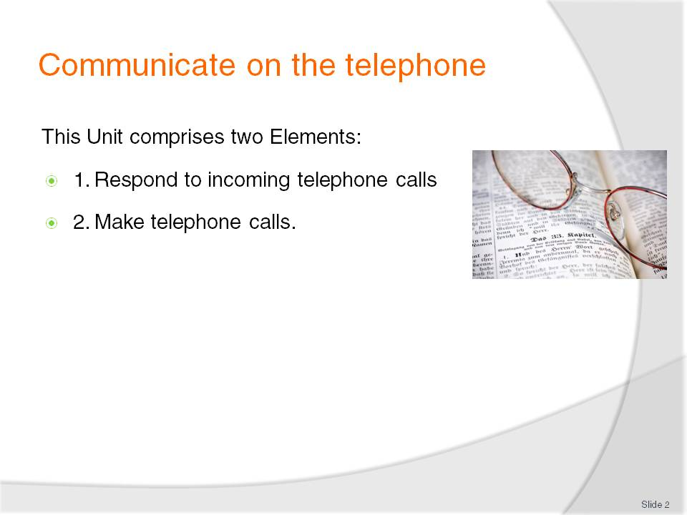
Slide No | Trainer Notes
Trainer advises students this Unit comprises two Elements, as listed on the slide explaining:
Each Element comprises a number of Performance Criteria which will be identified throughout the class and explained in detail
Students can obtain more detail from their Trainee Manual
The course presents advice and information but where their workplace requirements differ to what is presented, the workplace practices and standards must be observed.

Slide
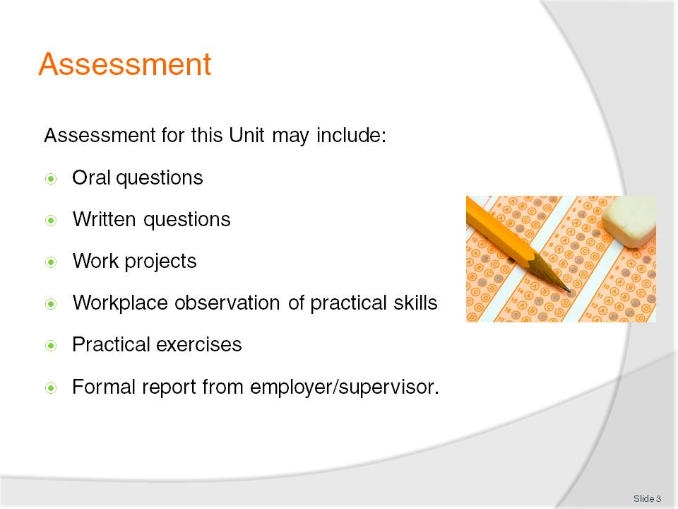
Slide No | Trainer Notes
Trainer advises students that assessment for this Unit may take several forms all of which are aimed at verifying they have achieved competency for the Unit as required.
Trainer indicates to students the methods of assessment that will be applied to them for this Unit.

Slide
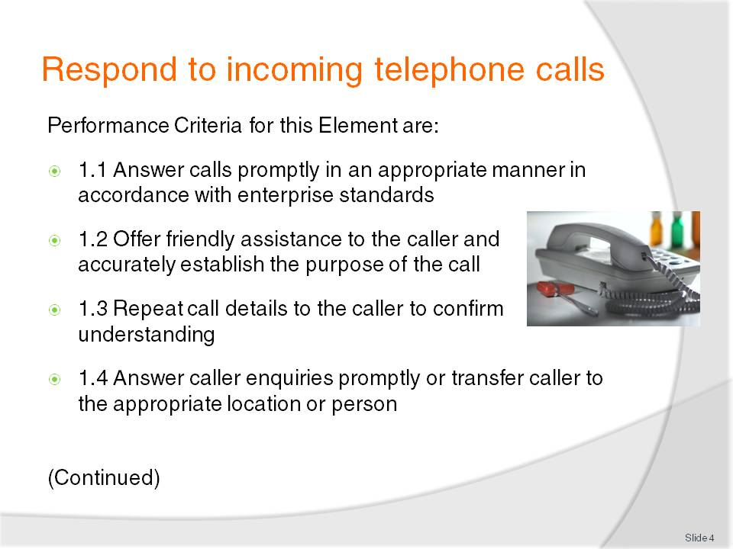
Slide No | Trainer Notes
 | Trainer identifies for students the Performance Criteria for this Element, as listed on the slide.

Slide
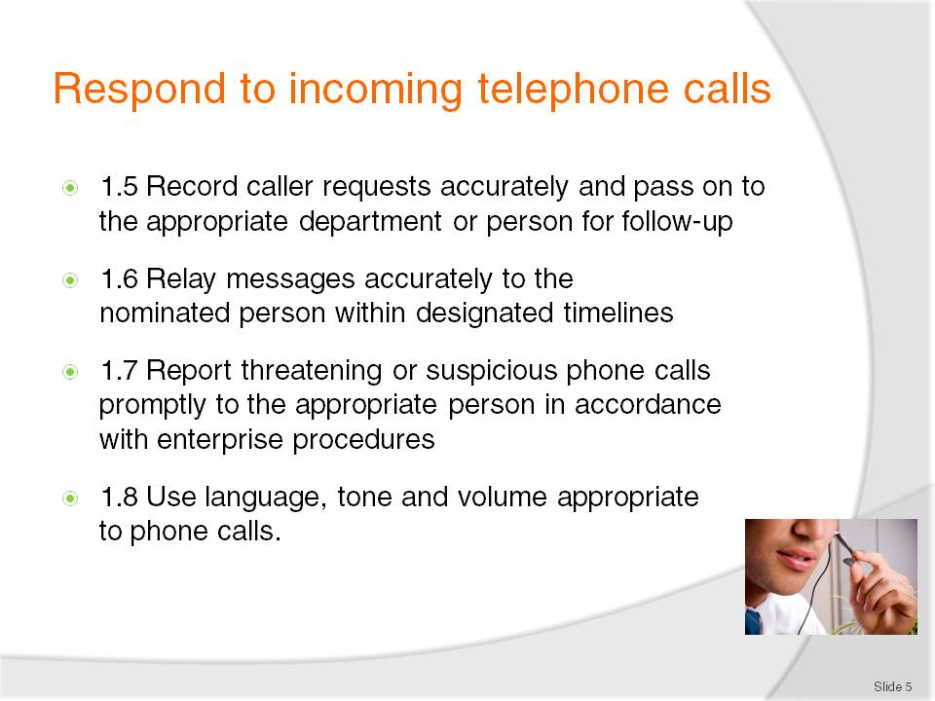
Slide No | Trainer Notes
Trainer continues to identify the Performance Criteria for this Element, as listed on the slide.
Class Activity – General discussion
Trainer leads a general class discussion on responding to incoming calls in the workplace asking questions such as:
What experience have you had of taking incoming telephone calls at work?
What sort of telephone system/s have you used?
What workplace requirements are you aware of in relation to the use of the telephone?
How should you answer an incoming call? What should you say?
How important is the telephone for a business?
What good or bad experiences have you experienced when someone at a business has answered a call you have made to them?

Slide
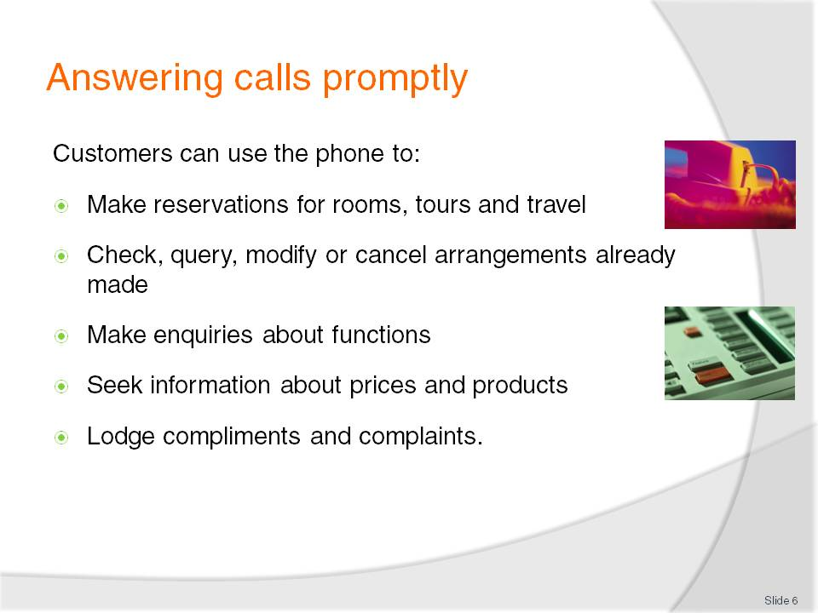
Slide No | Trainer Notes
Trainer states to students that nearly everyone thinks they can use a telephone competently because they all use one on a regular basis in their everyday, private lives highlighting that using a telephone in a workplace situation is completely different to using the telephone at home or using a cell phone.
Trainer explains to students that the telephone is vital to the operation of any business and is used by customers to contact the business for a variety of reasons such as to:
Make reservations for rooms, tours, travel and dining
Check, query, modify or cancel arrangements already made in relation to bookings, meetings, quotations etc
Make enquiries about functions and other services, products, facilities etc. the business offers
Seek information about prices and products including special deals, promotional packages, limited time offers
Lodge compliments and complaints regarding products and/or service they have received.

Slide
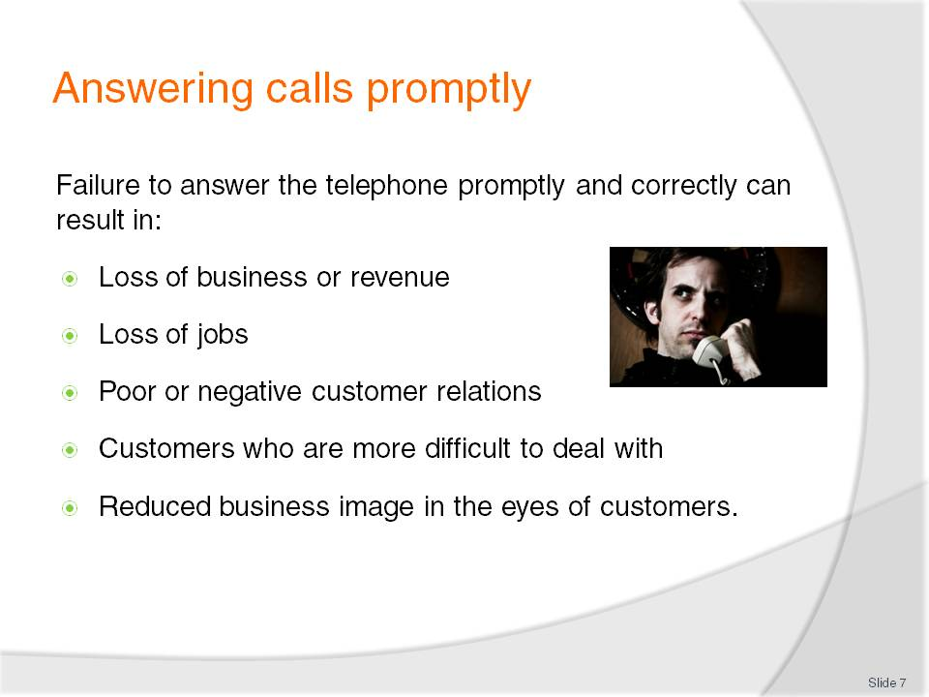
Slide No | Trainer Notes
Trainer explains the potential negative consequences of not answering the workplace phone promptly or correctly highlighting this may result in:
Customers taking their business elsewhere meaning loss of revenue for the business, and loss of jobs for staff
Poor customer relations meaning customers may be annoyed with the organisation and be more difficult to deal with or sell to
Reduced company image – the image of the business will be adversely impacted by poor telephone techniques.

Slide
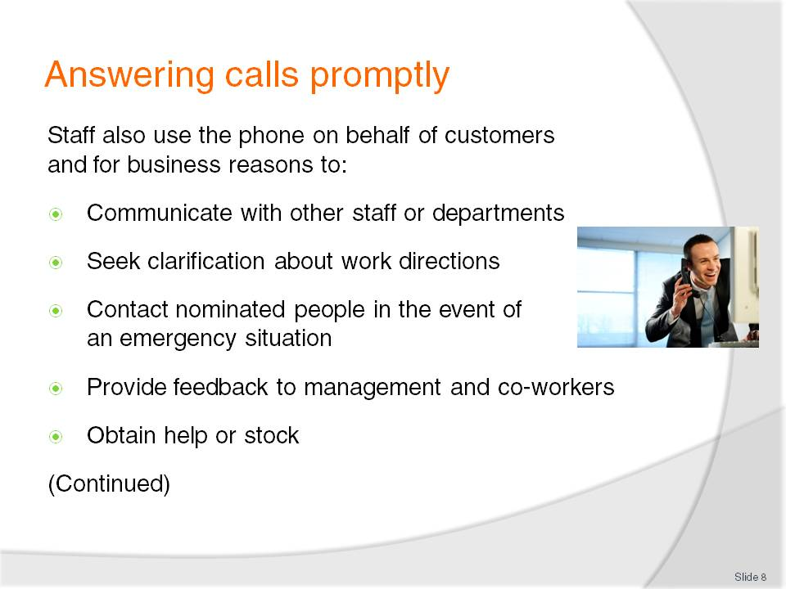
Slide No | Trainer Notes
Trainer explains to students that the telephone is also important for the business because it is used by staff to undertake numerous activities on behalf of both the business and its customers highlighting these activities may include:
Communicate with other staff or departments to pass on information, to advise of changed circumstances or arrangements and to find out information to use in their work
Seek clarification about work directions, such as identifying work priorities, obtaining resources to do their work or having unclear instructions explained
Contact nominated people in the event of an emergency situation, such as when there is a difficult customer, a fire or a medical emergency
Provide feedback to management and co-workers about service and customers, complaints, issues requiring attention (maintenance of equipment, products or services that customers do not like)
Obtain help or stock where unexpected levels of demand or trade occur and stock runs out, or extra help in dealing with customers is required.

Slide
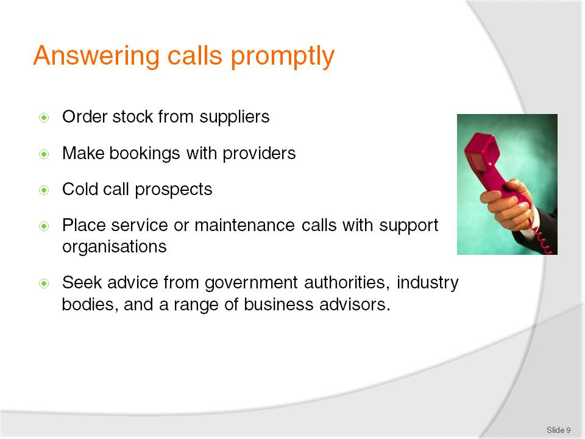
Slide No | Trainer Notes
Trainer continues to explain to students the ways in which staff can use the workplace telephone:
Order stock from suppliers. These are the resources and requirements a business needs to supply its customers
Make bookings with providers to reflect bookings made with them by their customers. While many bookings will be processed online there are frequent occasions when it is necessary to ring a provider and discuss a booking to make sure it is processed as required
Cold call prospects to generate sales or create bookings
Place service or maintenance calls with support organisations to arrange service, maintenance, repairs to workplace equipment, systems and technology
Seek advice from government authorities, industry bodies, and a range of business advisors to address needs related to a wide variety of operational needs such as security, legal, accounting and marketing/advertising.

Slide
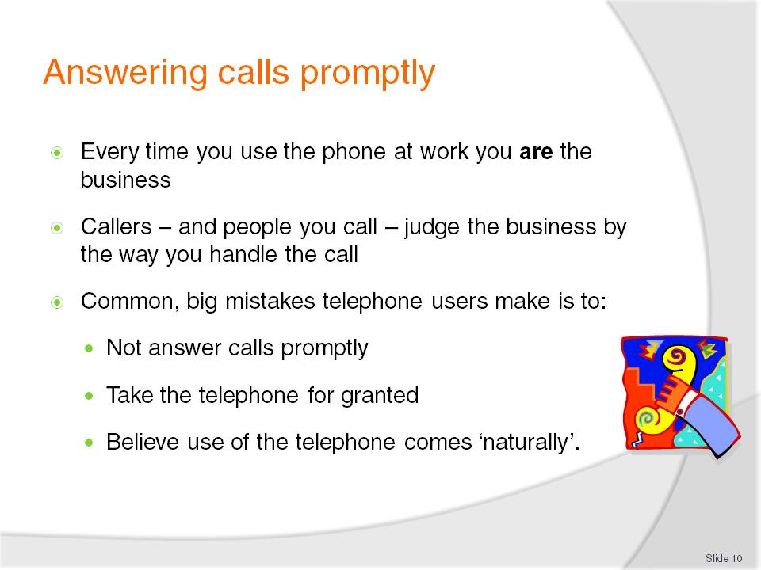
Slide No | Trainer Notes
Trainer urges students to remember that every time they use the telephone – whether this is to answer a call, or make a call – they are the business. Big mistakes workplace telephone users make is to:
Not answer calls promptly – calls should be answered as quickly as possible
Take the telephone for granted meaning they fail to pay sufficient attention to, and care with, the way they handle and process calls
Believe their use of the phone comes naturally to them and believe they do not need training in its correct use.

Slide
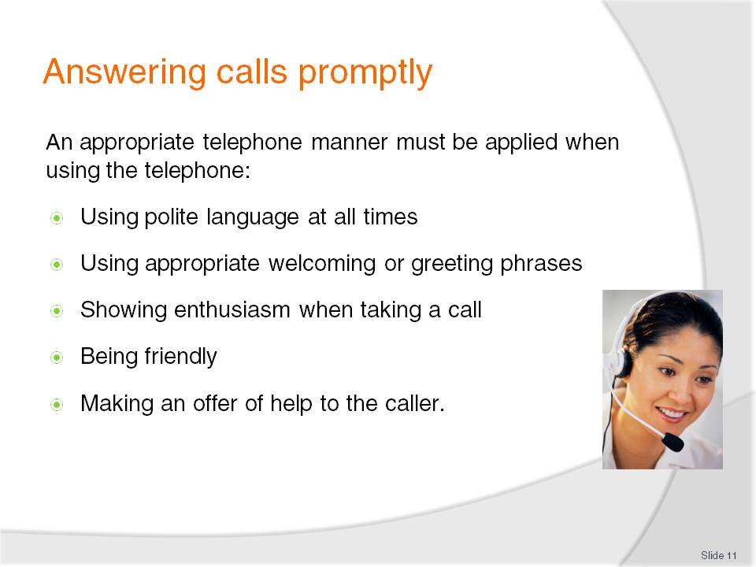
Slide No | Trainer Notes
Trainer advises students it is essential they use an appropriate telephone manner when using or answering the telephone, which includes:
Using polite language at all times regardless of the language being used by the caller [more information presented on later slides]
Using appropriate welcoming or greeting phrases as set by the employer. The style of the greeting should reflect the style of business involved [more information presented on later slides]
Showing enthusiasm (that is, a positive attitude or approach to the call) when taking a call. This is to demonstrate that the business is eager to talk to the caller and to do business with them
Being friendly. It is important for all those who take telephone calls to understand the need to be friendly to all callers. This friendliness while on the telephone has been referred to as the need to ‘put a smile in your voice’ when talking on the telephone. Some recommend placing a mirror near the telephone or on the desk to remind users to smile while on the phone
Making an offer of help to the caller. A standard requirement when answering all telephone calls is to either ask the caller a direct question enquiring what assistance the caller wants, or have a positive predisposition towards providing whatever help the caller asks for [more information presented on later slides].

Slide
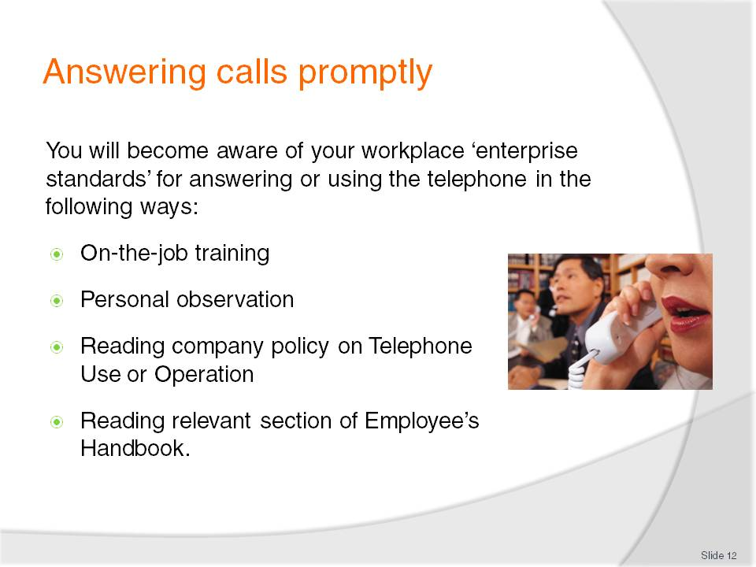
Slide No | Trainer Notes
Trainer advises students the enterprise standards that apply for answering or using the telephone in their workplace will be provided to them in one or more ways including:
On-the-job training – a formal course provided by the employer
Personal observation – listening to what others do or say
Reading the company policy on ‘Telephone Use/Operation’ (or similar) which will detail the exact requirements for all telephone use within the organisation
Reading the ‘Employee’s Handbook’ (or similar) which will provide a short-form of enterprise requirements and commonly contains sample phrases (such as greetings to use when answering a call, phrases to use when transferring a call and farewells to use when ending a call).
Class Activity – Consideration of workplace policies
Trainer obtains from local businesses a range of policies relating to Telephone Use and Standards and:
Shares these with students
Discusses them, highlighting specific workplace requirements
Identifies reasons behind workplace requirements as stated in the policies
Highlights policy requirements that differ from the way individuals us or answer a phone in their personal life.

Slide
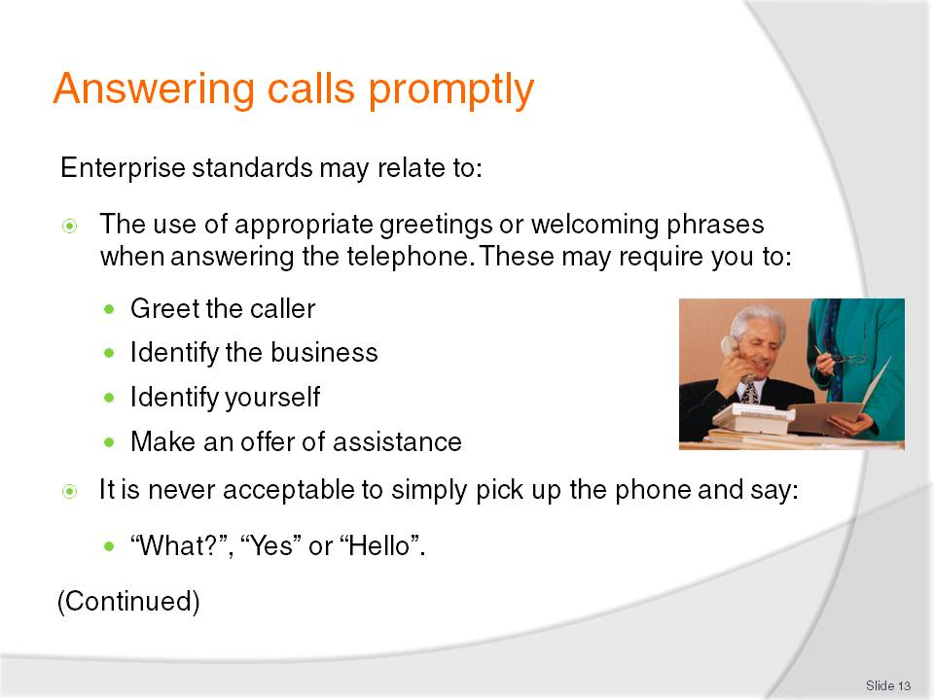
Slide No | Trainer Notes
Trainer advises students that ‘enterprise standards’ can vary between businesses but are similar in nature, highlighting they will normally require staff to make a standard statement when answering the phone in which they may, for example, require them to:
Greet the caller which may include a welcoming phrase dependent on the time of day: such as “Good morning”, “Good afternoon” or “Good evening”
Identify the business by the name advised by management. For example, the trading name of the business may not be the name management wants staff to use when answering the phone
Identify yourself following the nominated preferences of the business: for example, using either first or surname (or both)
Make an offer of assistance using a simple statement such as “How can I help you?”, “Where can I direct your call?” [More on later slides].

Slide
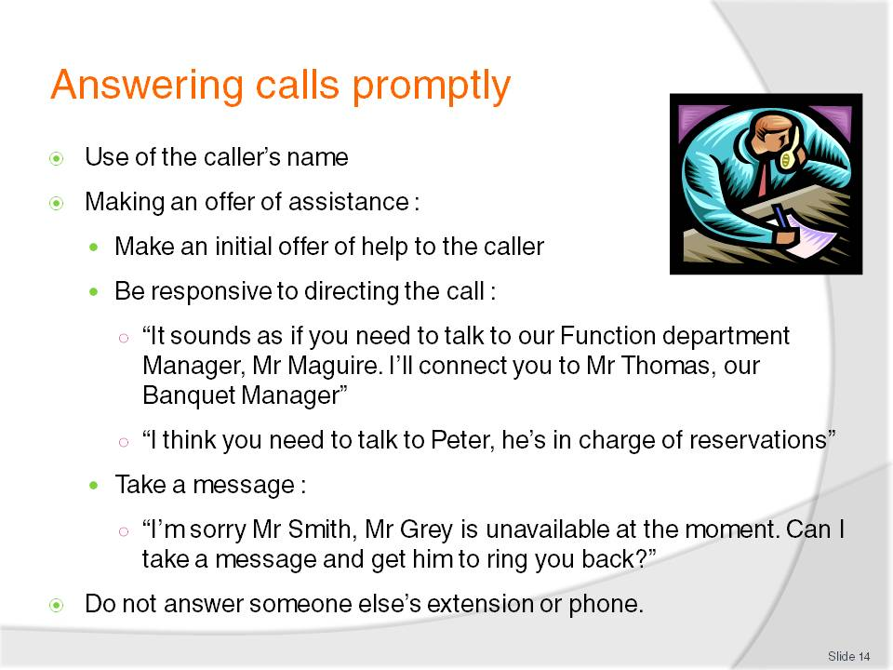
Slide No | Trainer Notes
Trainer continues to advise students about the possible requirements of enterprise standards as they relate to using or answering the workplace telephone:
Use of the caller’s name. When you know the name of the person calling it is standard practice to use that name throughout the duration of the call. It is often said everyone likes to hear the sound of their own name (so using the caller’s name is a positive thing to do), and it demonstrates to the caller you have taken the trouble to remember who they are. Using their name personalises the call.
Making an offer of assistance. When taking a telephone call you must always be alert to the need to (as appropriate):
- Make an initial offer of help to the caller – as identified on previous slide
- Be responsive to directing the call in accordance with the initial information provided by the caller:
- “It sounds as if you need to talk to our Function department, Mr Maguire. I’ll connect you to Mr Thomas, our Banquet Manager”
- “I think you will need to talk to Peter. He’s in charge of reservations”
- Take a message if the person the caller needs to speak with is unavailable [more on later slides]:
- “I’m sorry Mr Smith, Mr Grey is unavailable at the moment. Can I take a message and get him to ring you back?”
Do not answer someone else’s phone. Let the call be taken by an answering machine. Let it be automatically diverted by the system to another extension.
Class Activity 1 – Demonstration
Trainer uses Training Institute telephone system to show students how to answer the telephone in an acceptable manner using an assortment of appropriate enterprise standards.
Class Activity 2 – Role plays/practical exercises
Trainer presents students with several ‘workplace situations’ (describing time of day, name of the business the student represents etc.) and:
Plays the role of a customer and calls students in class using a Training Institute extension/telephone
Asks students to answer the call promptly and in an appropriate manner
Provides feedback to students after the role plays/exercises.

Slide
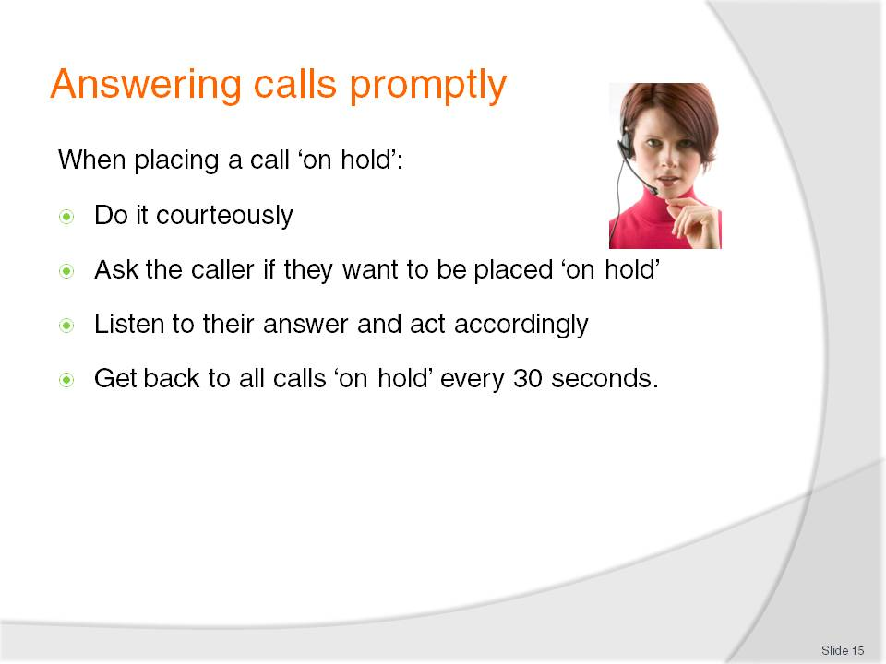
Slide No | Trainer Notes
Trainer explains to students that when a need arises to place a call ‘on hold’ they should:
Do it courteously following all applicable enterprise requirements
Ask the caller if they want to be placed ‘on hold’. Some callers may prefer not to be placed on hold. They may prefer to ring back or they may want you to take a message
Listen to their answer. When you have asked a caller if they wish to be placed on hold while you make enquiries you must listen for their response to the question. Never assume the caller will want to hold
Get back to all calls on hold every 30 seconds to advise them of your progress and to let them know you have not forgotten them so they know their call has not been disconnected.

Slide
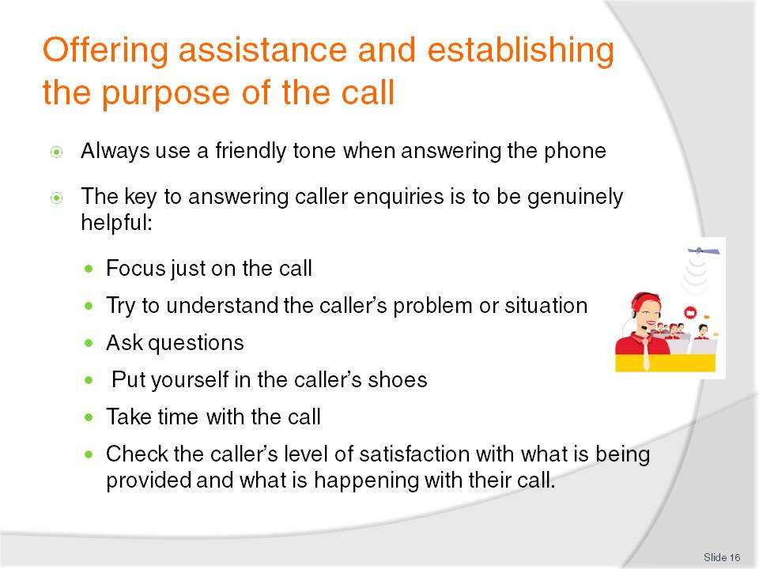
Slide No | Trainer Notes
Trainer reminds students that callers cannot see their facial expressions (that is, callers cannot read their body language to assist with the communication) when they telephone so this means it is more important for staff to use their voice appropriately.
Trainer mentions that at all times, callers must be spoken to in a friendly tone (‘put a smile in your voice’) and assistance must be offered when and where necessary without giving the impression that doing so is an imposition.
Trainer highlights to students the key to answering queries is to be genuinely helpful which encompasses:
Focusing on the call to the exclusion of other work: do not get distracted
Trying to understand the caller’s problem/s so your response or action is appropriate to the needs of the caller
Asking questions to obtain more information to assist in providing relevant help
Putting yourself in the caller’s shoes by seeing things from the caller’s perspective
Taking time with the caller by not rushing the call or giving the impression you are eager to move on to another call or to other work
Checking the caller’s level of satisfaction with what is happening, has been provided or is being suggested and altering service provision as necessary to improve service delivery.

Slide
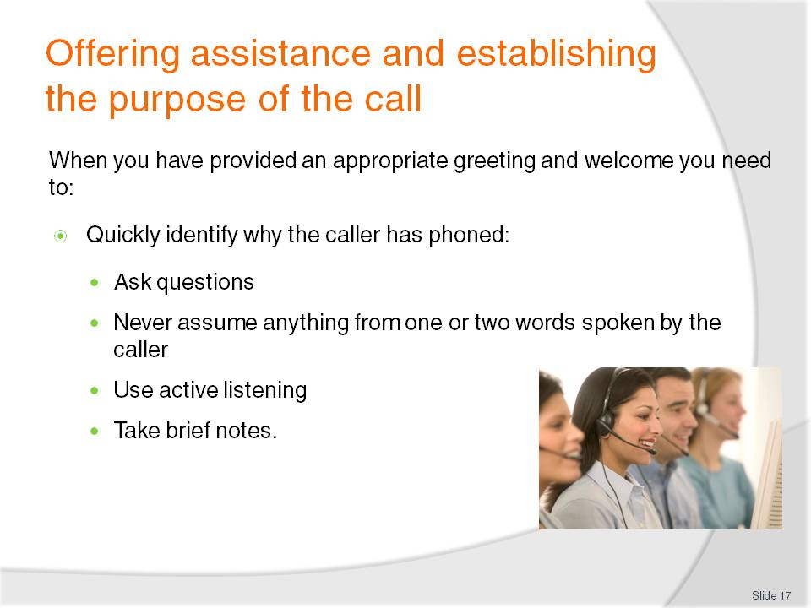
Slide No | Trainer Notes
Trainer explains to students that the first step after providing an acceptable greeting to the caller is to quickly establish the purpose of the call, highlighting they must never assume they know why the caller has phoned and stressing they must always be on their guard to prevent listening to just one or two words the caller says and jumping to a wrong conclusion about the reason for the call in the mistaken belief they think they are being helpful.
Trainer gives an example of the problem of assuming you know what the caller wants:
For example a caller says “I’m ringing about a reservation in the Grill Room” shouldn’t immediately be transferred to the Grill Room. They may have wanted to go on to say “I had a booking there the other night and there was a mix-up with it: I want to speak to the manager to make a complaint.”
Trainer explains to students keys in making sure they correctly establish the purpose of a call before processing it include:
Asking questions. It is common for people who answer telephone calls to have to ask the caller questions to better determine how or where to process their call. This is because the caller often fully understands what they want to say or who they want to talk to but they fail to convey this and appear to assume you know what they want to talk about and who they need to speak with.
Listening to information given by the caller. This highlights how critical it is for those who take incoming telephone calls to apply ‘active listening’ techniques and focus completely on the words being spoken by the caller
A useful strategy when establishing the purpose of a call is to jot down notes about what the caller is talking about. This provides a visual reference that jogs the memory and always helps to determine what the caller wants and where their call should be transferred.
Slide
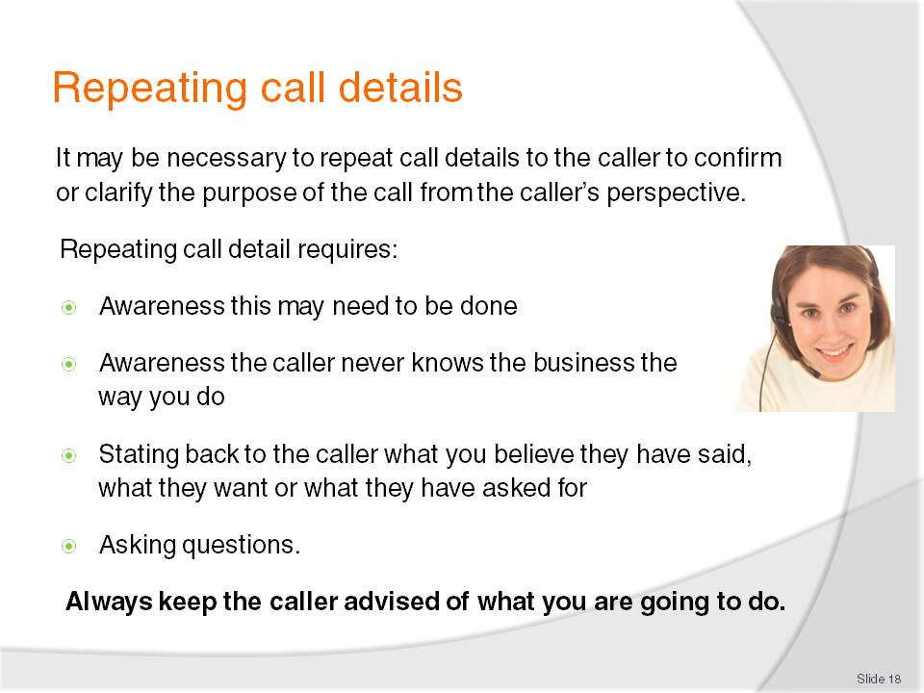
Slide No | Trainer Notes
Trainer explains to students that it may be necessary to repeat call details to confirm or clarify understanding regarding caller requirements, to save valuable time for the caller and make sure the call is connected to the right person or department.
Trainer identifies that confirming understanding of caller requirements involves:
Awareness this may need to be done. Repeating call details is not required for every call but there is always a requirement you remain alert to the possibility you may need to clarify or confirm call details
Awareness the caller never knows your workplace in the same detail you do. They may have no understanding at all, or some understanding but they will never know your workplace to the same extent you do (that is, all the policies and procedures; staff names, roles and responsibilities; options, prices, deals etc.)
Stating back to the caller what is they have said, asked for or requested to make sure you have it right and to give them a chance to clarify and/or add more detail or information
Asking questions to obtain more detail where the caller has not provided it, or to clarify points where the caller was unclear in what they said or asked for.
Trainer advises students they should always keep callers informed about what they intend doing in relation to their call. This may include:
Advising them you can help them, take their booking, provide the information they are seeking
Informing them you are going to transfer their call to a nominated department or person
Asking if they would like to hold while you obtain required information.
Slide
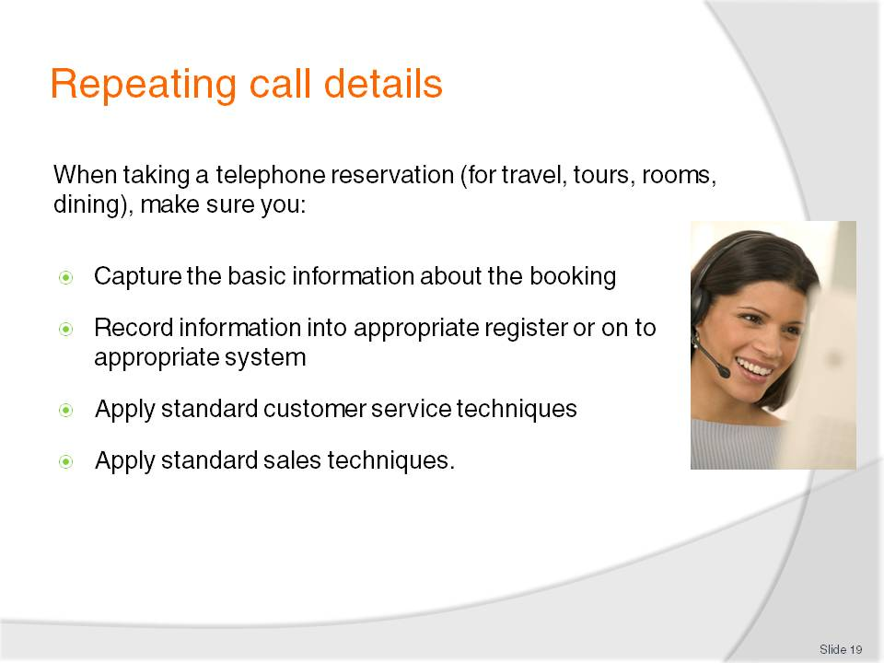
Slide No | Trainer Notes
Trainer advises students that most requests for a reservation will be forwarded to the appropriate area or person for them to handle stating this procedure is most effective because it allows the appropriate staff member to obtain extra information from the caller, arrange the best reservation for the caller and confirm (or deny) the booking.
Trainer indicates to students that where they are required to take a phone call and process a reservation as part of that call they must pay attention to:
Capturing all relevant details applicable to the type of reservation being processed, which may include:
- Day and date: both should be confirmed as a means of making sure the correct date is being provided
- Time – checking about AM or PM and using the 24-hour clock in many cases
- Names – with special attention paid to capturing all relevant names and ensuring the spelling of people’s names and business names is correct
- Numbers involved in the booking and, where appropriate, noting gender and ages (especially where it is important to differentiate between adults and children)
- Preferences – these relate to individual preferences for people making the booking such as, for example, location of seat [aisle/window], location of table (near window, near band) or specifications about a room (with a view, quiet, with a spa): most of this will be offered by the caller but some information will need to be asked for
Trainer advises details regarding taking of reservations will be explained in more detail in other relevant Units.
Entering the information into the correct book or register or on to the correct CRS [Computerised Reservation System] system (or field within the system)
Applying standard customer service techniques which may include:
- Repeating back reservation details – see below
- Quoting reference or booking numbers, where necessary or appropriate
- Thanking the caller for their call/booking. All callers must be thanked, even where they only make an enquiry and do not make a booking
- Asking if you can be of extra service – “Is there anything else I can do for you today, Mr Cox?”
Applying standard sales techniques which may include:
- Providing information on products, services, facilities, deals, policies, terms and conditions etc
- Up-selling and on-selling as appropriate to the nature of the caller or sale
- Selling the benefits as opposed to selling only the features of a product or deal.
Class Activity 1 – Demonstration
Trainer uses Training Institute telephone system to show students how to process a telephone reservation for a room, tour, travel or dining. Trainer plays the role of a staff member taking the booking and a student plays the role of the customer or caller.
Class Activity 2 – Role plays/practical exercises
Trainer plays the role of a customer and calls students using a Training Institute extension/telephone to make a reservation for room, tour, travel or dining (as appropriate to the nature of student workplaces) asking them to:
Capture and record required information
Apply necessary customer relations and selling skills.
Provides feedback to students after the role plays/exercises.

Slide
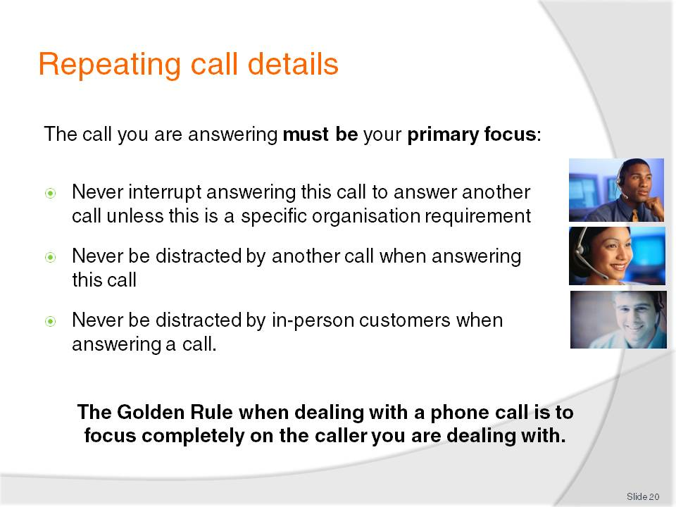
Slide No | Trainer Notes
Trainer highlights to students that when they are using or answering the telephone at work it is vital they focus on the call and on what they are doing.
Trainer states students must try to never:
Interrupt answering this call to answer another call. The aim should be to deal with once call at a time, and deal with it fully before moving on to another call
Be distracted by another call when answering this call. The need to get back to a call ‘on hold’ must take second place to dealing with the current call
Be distracted by in-person customers when answering a call. Enterprise standards or requirements in this regard must be observed but a call you are already dealing with must take priority over an in-person customer who arrives. By the same token, most businesses will require an in-person customer to be dealt with as a priority over a phone call that comes in.

Slide
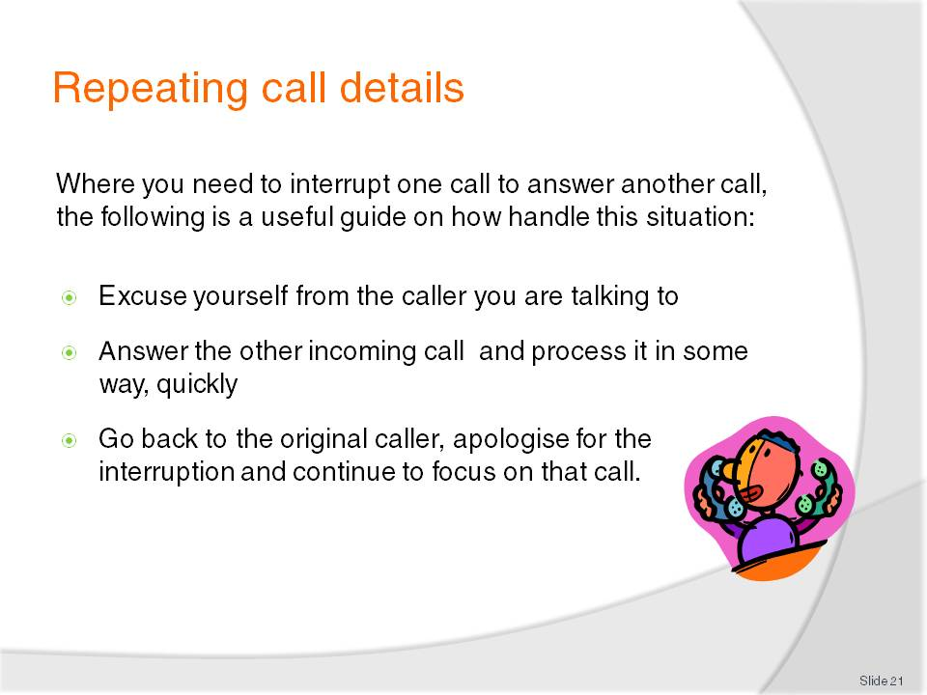
Slide No | Trainer Notes
Trainer reminds students standard telephone practice is not to interrupt one call to answer another call, but where there is a need to do so they should:
Excuse yourself from the caller you are talking to
Answer the other incoming call and either:
- Apologise for the delay
- Ask them if they would mind holding
- Put them on hold, take their details and offer to call them back, or (not the preferred option) ask if they would mind ringing back
- Transfer the call to the appropriate person or department
Go back to the original caller and apologise for the interruption and continue to focus on that call. Note that in some situations you will have to make a value judgment about whether to ignore the other incoming call and simply continue with your existing call.

Slide
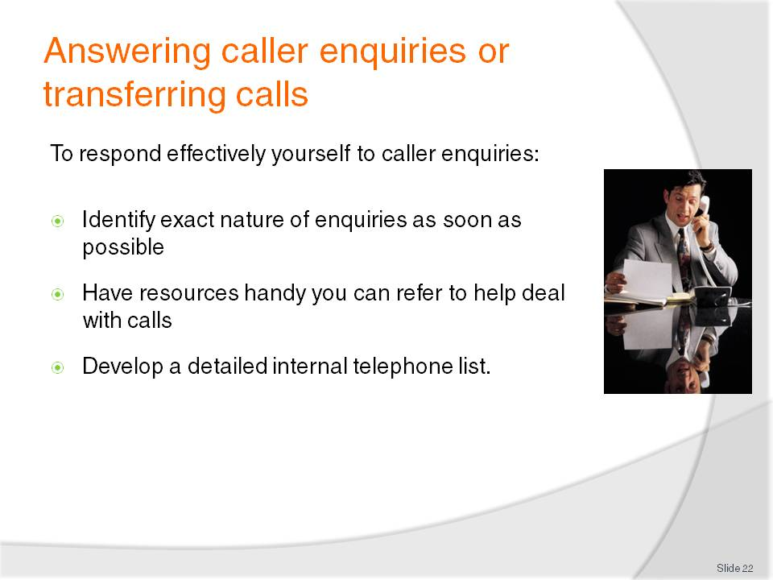
Slide No | Trainer Notes
Trainer advises students when they answer a call they commonly will either need to answers a caller enquiry, or transfer the call to another person or department.
Trainer instructs students that to answer caller enquiries themselves they need to:
Identify the exact nature of the enquiries as soon as possible. This will indicate to you whether or not you can deal with the call or whether you need to transfer the call to someone else, or take a message and get back to the caller
Have resources handy to the telephone that you can refer to help deal with the call. These resources may be company operating manuals, copies of policies and procedures, advertising material, copies of room rates, menus, schedules etc.
Develop a detailed internal telephone list identifying all staff in the business and their extension numbers, mobile numbers, pager numbers etc. so you can use this to seek assistance from other staff and/or transfer the call as necessary.

Slide
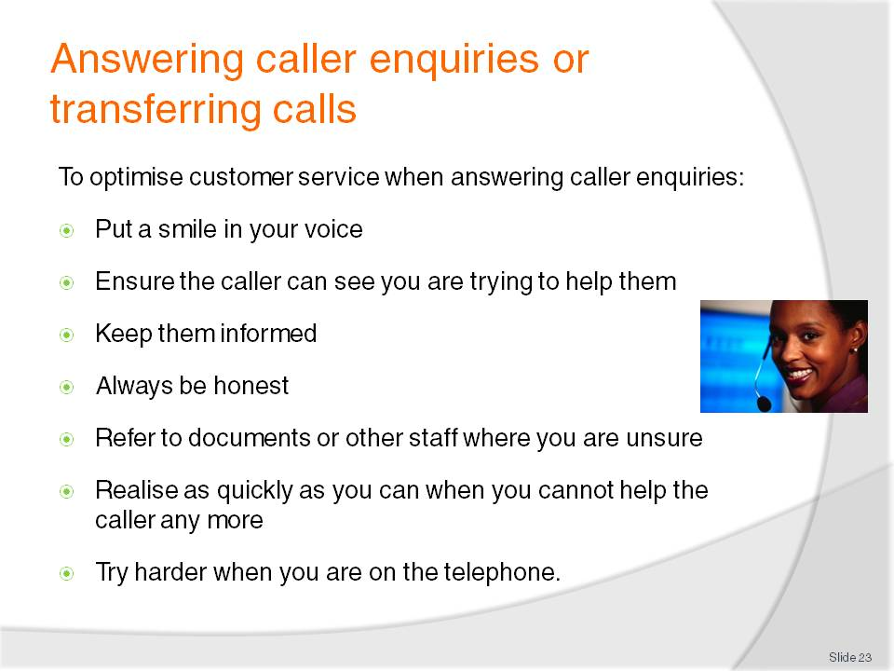
Slide No | Trainer Notes
Trainer informs students the following techniques should be applied when answering caller enquiries in order to optimise customer service:
Put a smile in your voice (if appropriate – that is, it is inappropriate to put a smile in your voice if the caller is calling to make a complaint). Callers cannot see you so the sound of your voice is critical
Ensure the caller can see you are trying to help them. I is important you become part of the solution to the reason they called, as opposed to becoming an additional problem for them to deal with
Keep them informed. Tell the caller what you are doing to try to help them. Remember they cannot see you so you have to tell them what you are doing
Always be honest. Never make up an answer if you don’t know, and make sure you tell the caller the full story in response to their question as opposed to just giving them half the story thereby misleading them and/or creating false or unreal expectations
Refer to documents and other staff where you are unsure. For example, prices change and advertising promotions/campaigns alter over time. Where you are not 100% sure of your facts, look it up or ask the ‘right person’
Realise as quickly as you can when you cannot help the caller any more or at all. Callers get quickly annoyed at having to explain themselves to you and then having to do the same thing all over again to another person: never waste the caller’s time
Try harder when you are on the telephone. Make an extra effort when dealing with people on the telephone in recognition of the fact they cannot see you and you cannot see them. Ensure your voice is appropriate and reflects the emotion you want to convey.
Slide
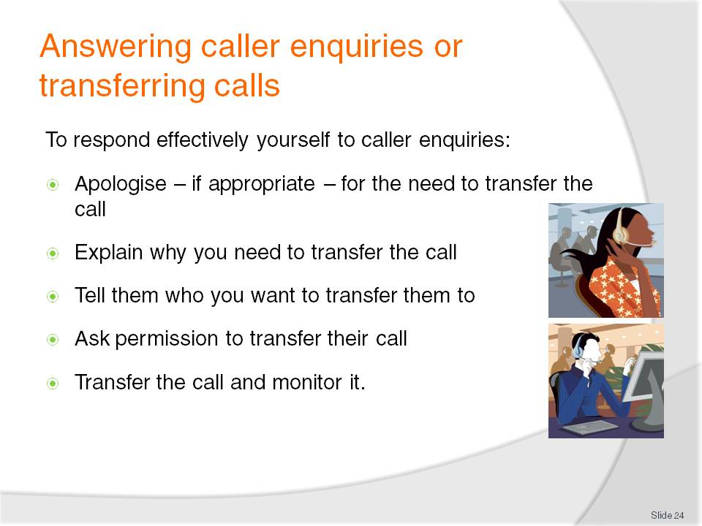
Slide No | Trainer Notes
Trainer informs students their workplace may have standard protocols for them to follow when transferring calls and if they exist they must be adhered to.
Trainer indicates standard telephone procedures for transferring calls include:
Apologise – if appropriate – for the need to transfer the call. Where the caller has asked for another person there is obviously no need to apologise
Explain why you need to transfer the call. Highlight the fact the person they are being transferred to will be best able to deal with their call
Tell them who you want to transfer them to. Give the person’s name and tile/position within the business
Ask permission to transfer their call, for example:
- “Mr Watts, I’m sorry I can’t help you with your query but I’d like to transfer you to Mr Brown who is the manager. Would you like to be connected to him?– I’m sure he will be able to give you the information you need”
Transfer the call and monitor it. If the call isn’t answered you must go back to the caller, apologise and make arrangements for the business or person to phone the caller back.
Class Activity – Demonstration and practical exercise
Trainer uses the Training Institute telephone system to demonstrate to students how to transfer a telephone call [Trainer may elect to use reception or administration staff to demonstrate this] and then:
Uses Training Institute telephone system to call students and request someone or a department that will necessitate students transferring the call.
Slide
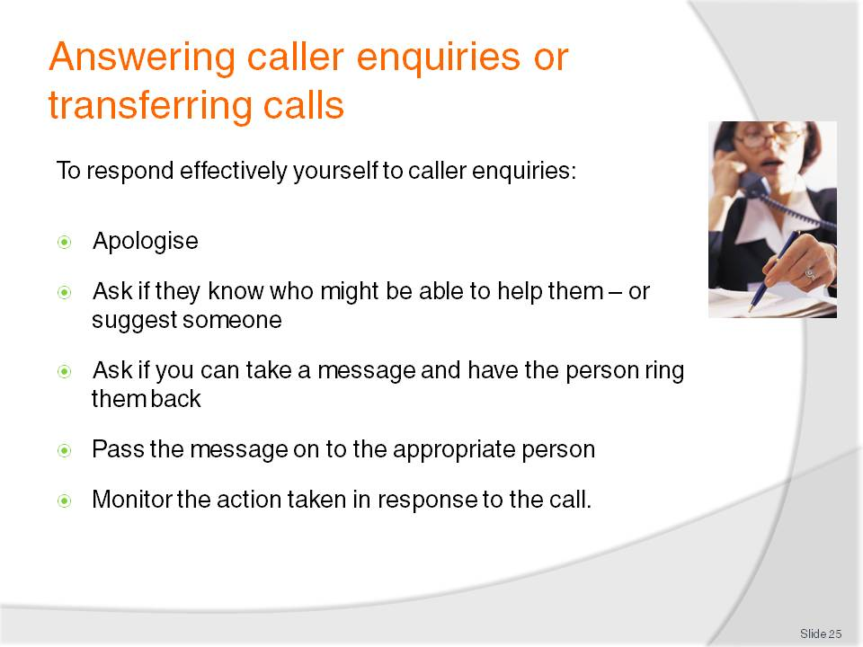
Slide No | Trainer Notes
Trainer advises students where the caller has asked to talk with someone who is unavailable they should:
Apologise and tell them the person is unavailable but do not disclose where they are or why they are away
Ask if they know of anyone else who might be able to help them. This may involve you politely asking them the reason for their call so you can place it appropriately, or suggest another person who may be able to assist
Ask if you can take a message and have the person concerned ring them back. Then take a short but comprehensive message, repeating back the details to the caller (see section 1.5 for more details)
Pass the message on to the appropriate person to make sure they receive the message. Always remember taking a message is only part of the job. It is equally important to make sure it is passed on (see section 1.6)
Monitor the action taken in response to the call. For example, if the person who was required to reply to the call cannot be contacted, or is unable to answer, then you must provide quality service by telephoning the caller and advising them that even though their call has not been answered as intended, it has not been forgotten and will be dealt with shortly (by another person, where appropriate). You must keep trying to contact the caller, in this situation, until you are able to speak with them. It is not acceptable to ring once, be unable to talk to them and then ignore the situation.

Slide
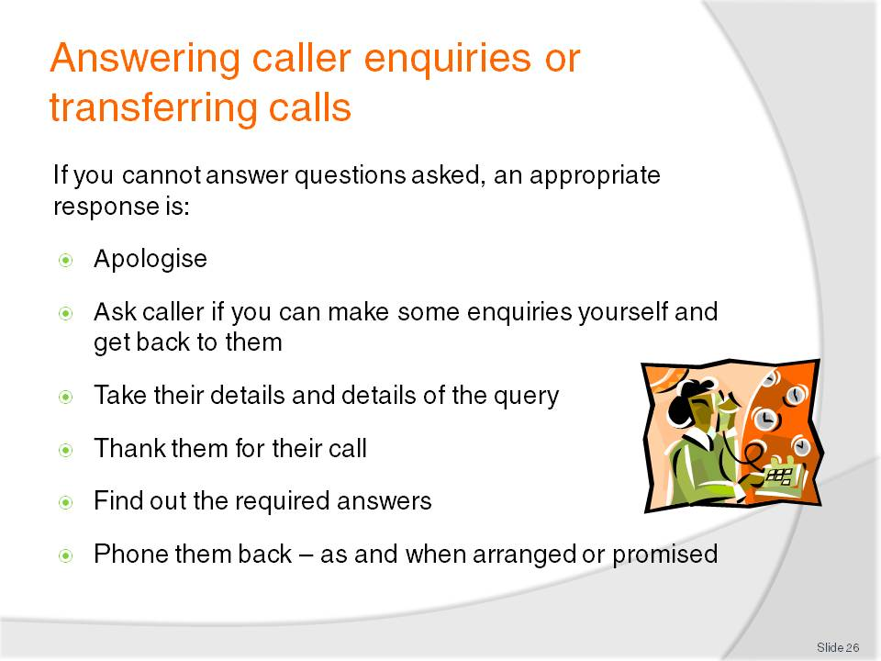
Slide No | Trainer Notes
Trainer informs students in some cases they will be the person who the caller needs to speak to, and they will be unable to answer all questions asked of them. When this occurs an appropriate response is to:
Apologise quickly and sincerely. If you don’t know the answer to a question then the sooner you identify this and inform the caller, the better
Ask the caller if you can make some enquiries yourself and get back to them. Remember to ‘ask permission’ rather than ‘tell them’ what you are going to do
Take their details and details of the query. Write down their contact details, ask the best time to call back and capture all the details about the query
Thank them for their call and confirm you will phone them back at the agreed time on the agreed number
Find out the required answers. Ask other staff, research price lists, policies, schedules, menus etc.
Phone them back as and when arranged or promised. If there is difficulty obtaining the required information, follow procedures as set out on next slide?

Slide
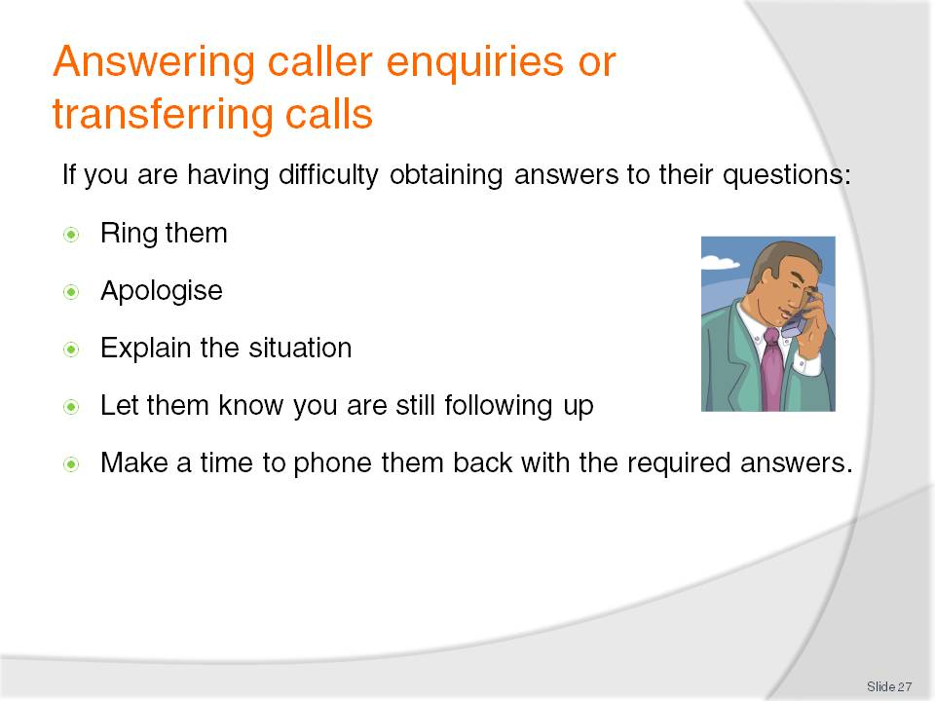
Slide No | Trainer Notes
Trainer informs students if they are having difficulty obtaining answers to callers questions as promised they should:
Ring them and let them know you have not yet got the answer
Apologise – sincerely but briefly
Explain the situation – inform them why you are having difficulty (for example, the person you need to talk to may be away; the system may have crashed)
Let them know you are still following up to demonstrate you are working for them and on their behalf
Make a time to phone them back with the required answers and repeat this process where you still cannot find answers.

Slide
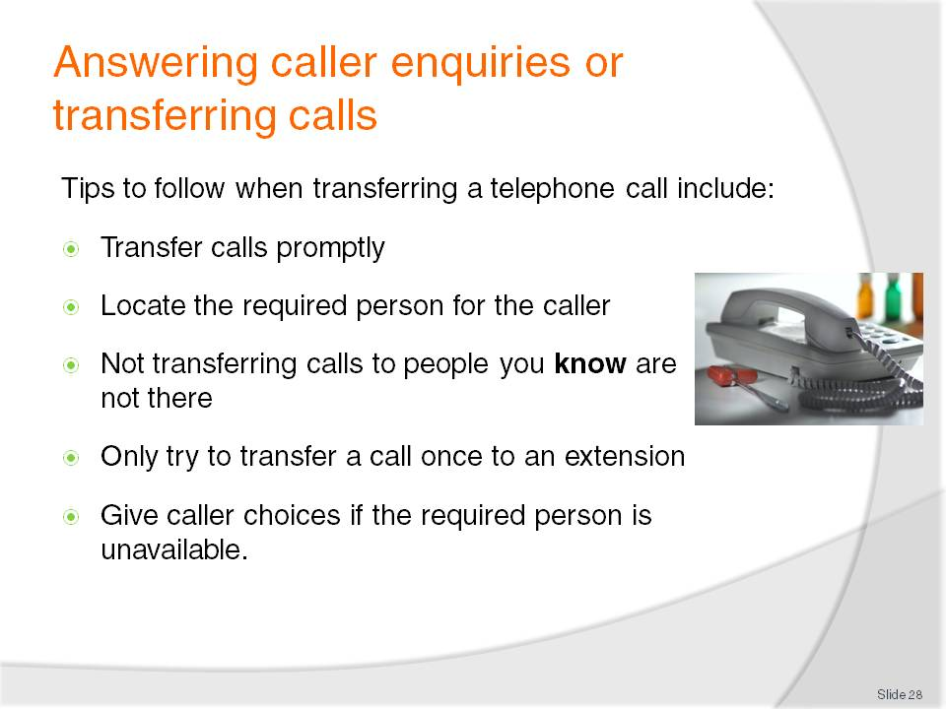
Slide No | Trainer Notes
Trainer provides students with tips to follow when transferring a phone call to another extension:
Transfer calls promptly. Quickly identify if there is a need to transfer the call or not
Locate the required person for the caller where necessary or appropriate, while the caller is on hold. Do this quickly and advise them there is a call for them
Not transferring calls to people you know are not available. There is no point transferring a call to, for example:
- Someone you know is away, sick
- Someone who is on another call, or busy with a face-to-face customer
Only try to transfer a call once to an extension. It is standard practice in most workplaces not to re-try transferring a call to an extension that was busy or unavailable
Give caller choices if the required person is unavailable, such as:
- Continuing to hold
- Leaving a message
- Having the business call them back
- Calling back again later.

Slide
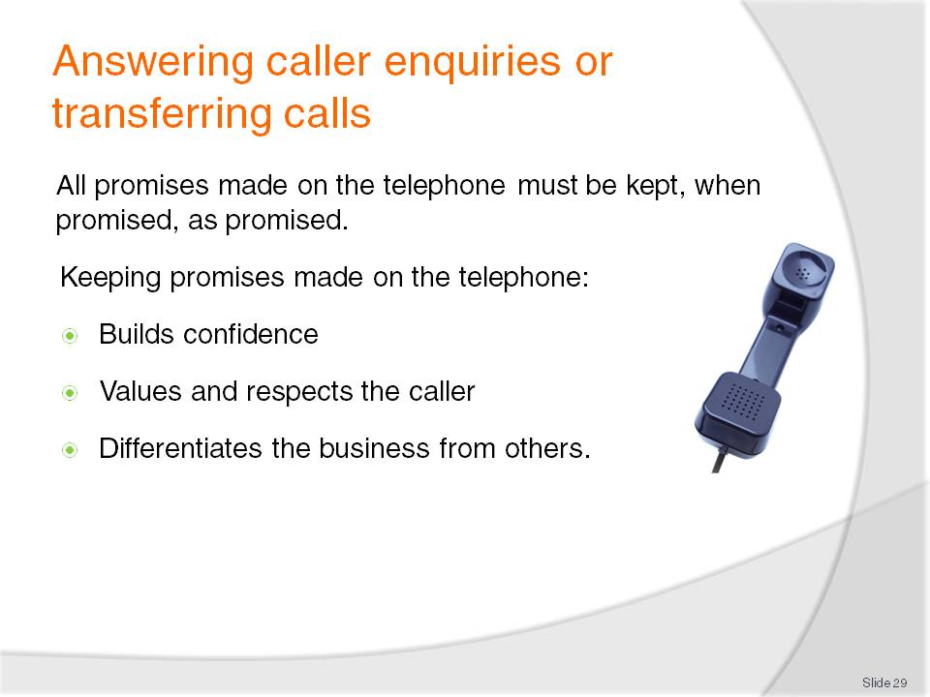
Slide No | Trainer Notes
Trainer stresses to students that all promises made on the telephone to a caller must be kept.
Trainer explains by stating (for example):
If a promise is made to call them back then they must be called back
If a promise is made that Mr. Sing will call back, Mr. Sing must call back
If a promise was made to call back before 5:00PM, the call must be made back to them before this time.
Trainer highlights that keeping promises made on the telephone is a great way of:
Building customer or caller confidence in the business. If promises made on the telephone are honoured, callers believe other promises made by the business when they do business with them will also be honoured
Valuing the business of the caller by demonstrating the organisation wants to do business with the caller
Respecting the caller by extending the common courtesy of doing what was promised
Differentiating the business from nearly every other business. Most other businesses do not keep their promises so this is a simple and effective way to show how your business differs to the competition.

Slide
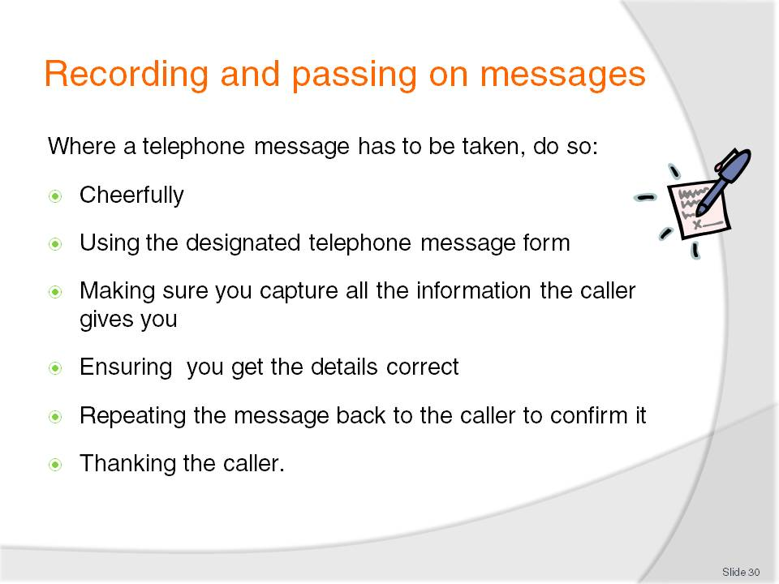
Slide No | Trainer Notes
Trainer instructs students if the caller asks to leave a message or it becomes obvious a message needs to be taken, high levels of customer service must be provided and they must be on their guard to never give the impression that having to take a message is a nuisance or a burden.
Trainer explains taking a telephone message must be done:
Cheerfully. The same level of customer service must be provided as dealing with all other aspects of telephone operation.
Using the designated telephone message form – see following slide
Making sure you capture all the information the caller gives you. The message must be meaningful and comprehensive. Remember another person will have to read, interpret and act on it
Ensuring you get the details (times, dates, numbers, prices, addresses, flight numbers etc.) correct – double-check them. Special attention needs to be paid to spelling of names, addresses, towns etc. Ask the caller to spell out names and destinations if unsure of the spelling or where variations on traditional spelling exist
Repeating the message back to the caller to confirm it and allow them to provide extra information or detail or change the details already provided and make corrections (adjustments, additions etc.) as required
Thanking the caller for their call, leaving a message, calling back etc.

Slide
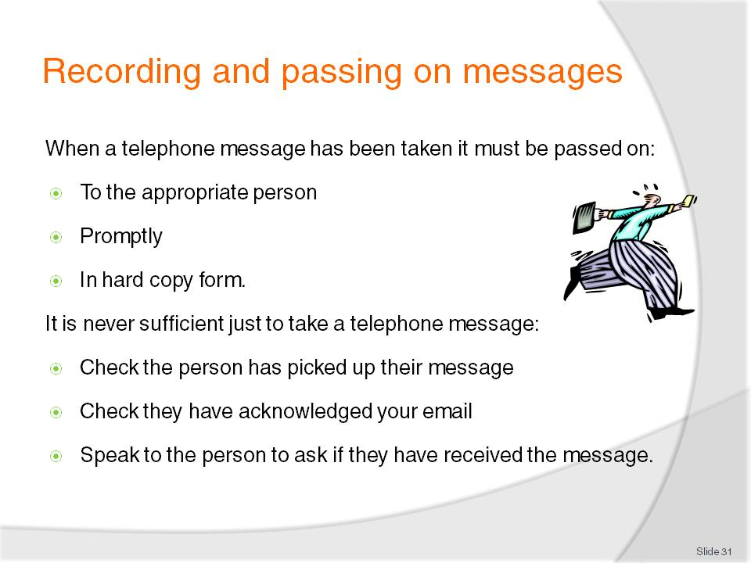
Slide No | Trainer Notes
Trainer informs students once a message has been taken it must be passed on:
To the appropriate person or department, as appropriate
Promptly – which translates into ‘as soon as possible’
In hard copy form. It is rarely acceptable simply to pass on a verbal message.
Trainer also advises students that to make sure the appropriate person has received their message they may:
Physically check the staff notice board, or pigeon hole to see whether or not they have picked up their message
Check the email system to verify a Read Receipt has been received acknowledging an email alert/message has been received
Speak one-to-one with the person – in person or over the phone to confirm they have received their message.

Slide
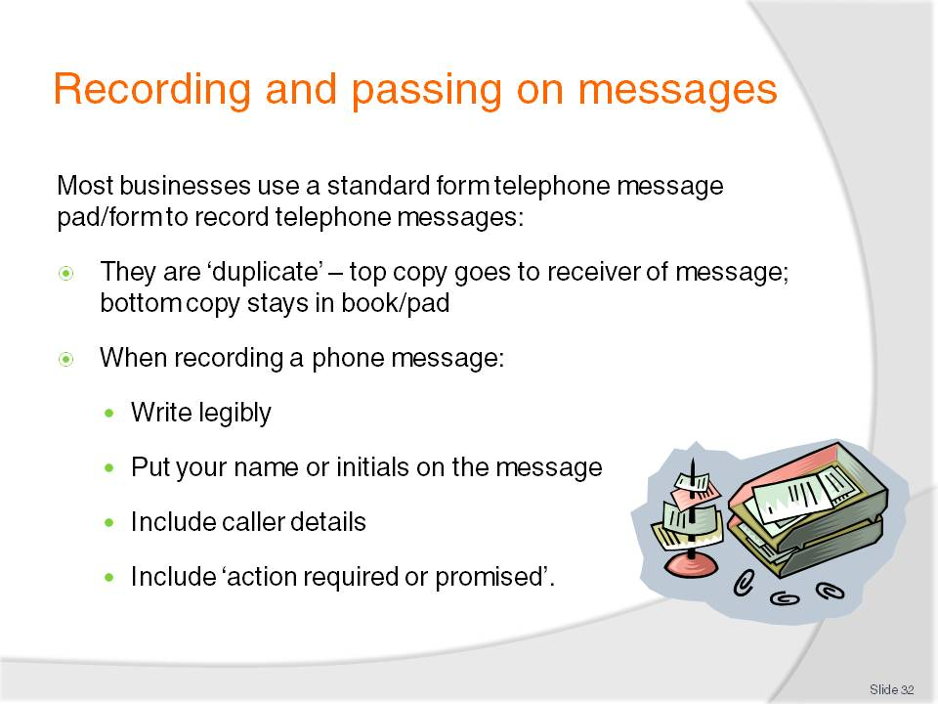
Slide No | Trainer Notes
Trainer tells students many businesses have a paper-based message book or a pad of ‘telephone message’ slips for recording telephone messages, highlighting these may be produced by the business for their individual use but most businesses will use a commercially available option found at stationers.
Trainer explains:
These books/pads are duplicate in nature. The top copy is given to the person for whom the message is intended and the duplicate or bottom copy stays in the book/pad.
If the top copy is lost, the duplicate copy can always be used as a reference.
When recording a telephone message ensure:
- Legibility – remember that someone else has to read it
- Put your name/initials on it so the recipient knows who took the message, allowing them to contact you for more information
- You record the caller’s name, phone number, nature of the call, query or message, and date and time of the call
- What action the recipient is required to take, if any – such as ‘ring back’, ‘forward function Information Kit’ etc: Remember this is a promise made to the caller so it is important it is kept.

Slide
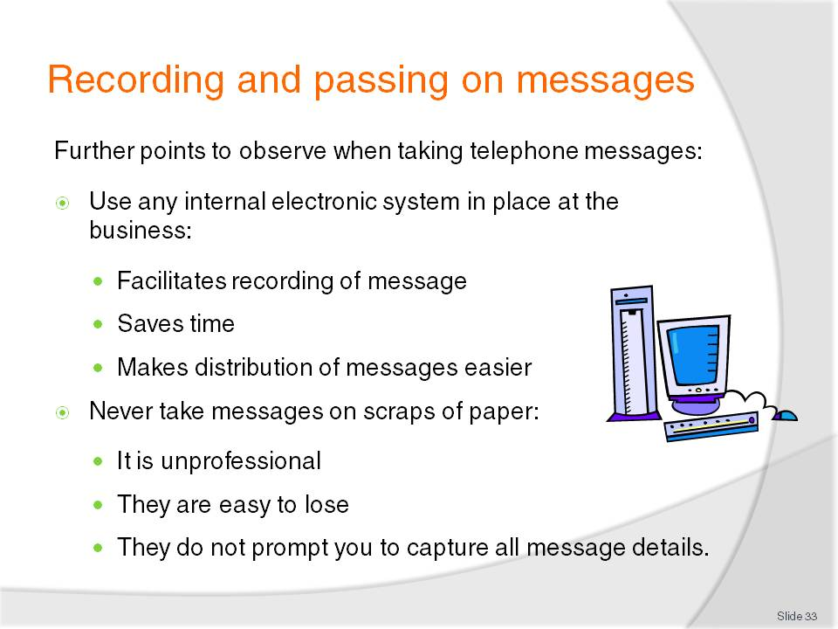
Slide No | Trainer Notes
Trainer informs students that when taking telephone messages:
An electronic option to the paper-based ‘telephone message’ may exist in their workplace. This is either a template facility, intranet or internal email and facilitates both the recording and distribution of telephone messages
The use of scraps of paper to record telephone messages must be avoided at all times because:
- They are unprofessional. It looks bad to any customer who sees what you are doing
- They are more easily lost. Messages in a telephone message book stay in place until physically removed
- They do not prompt the message take to ask the necessary questions. The sections on a telephone message pad function as prompts as to what questions to ask the caller in order to capture all the necessary call details.
Class Activity 1 – Distribution of telephone message forms
Trainer obtains sample telephone message forms and distributes them to students, identifying the sections on the forms and explaining what each is used for.
Class Activity 2 – Exercises/simulation
Trainer arranges for:
Students to answer Training Institute telephone in their class and take a message (on a Telephone message Pad/Form) from another student, playing the role of a customer leaving a message for a staff member or department.
Slide
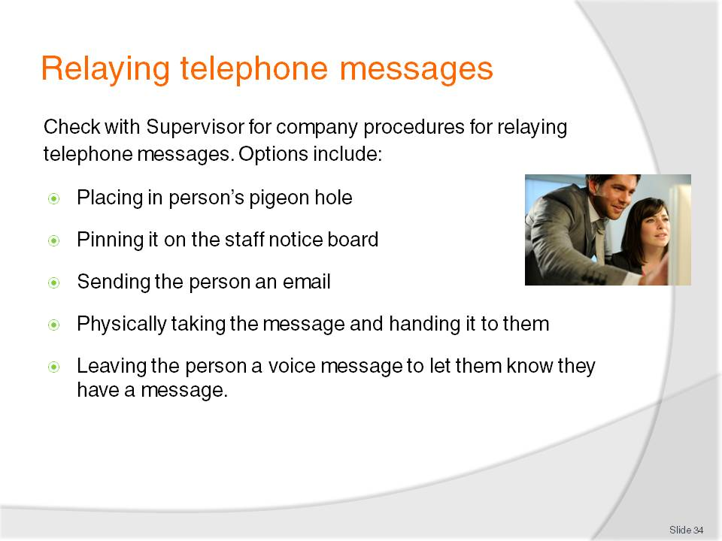
Slide No | Trainer Notes
Trainer reminds students it vital for all telephone messages to be passed on.
Trainer explains to students options for relaying messages may be covered by a company policy (so they must check with their Supervisor) but options may include:
Placing the top copy of the telephone message form into the person’s pigeon hole for them to collect. This is not acceptable where the message is urgent
Pinning it to the staff notice board
Sending the person an email – see previous section re electronic templates for phone messages
Physically taking the message and giving it to the person (handing it to them – this is appropriate where the matter is urgent)
Leaving the person a voice message to let them know they have a message and asking them to (as appropriate) contact you, check their email, pick the message up from their pigeon hole etc.

Slide
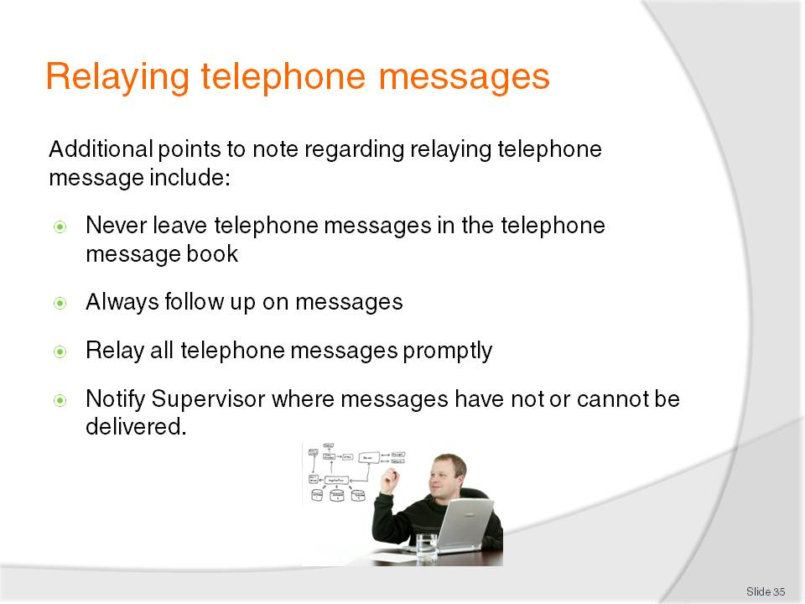
Slide No | Trainer Notes
Trainer provides additional information to students regarding the relaying of telephone messages:
Never leave telephone messages in the telephone message book. It must be forwarded according to need or company policy
Always follow-up on messages to make sure they have been received and/or actioned
Relay all telephone messages promptly. The standard timeline is ‘as soon as possible’
Notify Supervisor where messages have not or cannot be delivered. If a message has not been passed on or actioned in 24 hours the Supervisor should be advised of this.

Slide
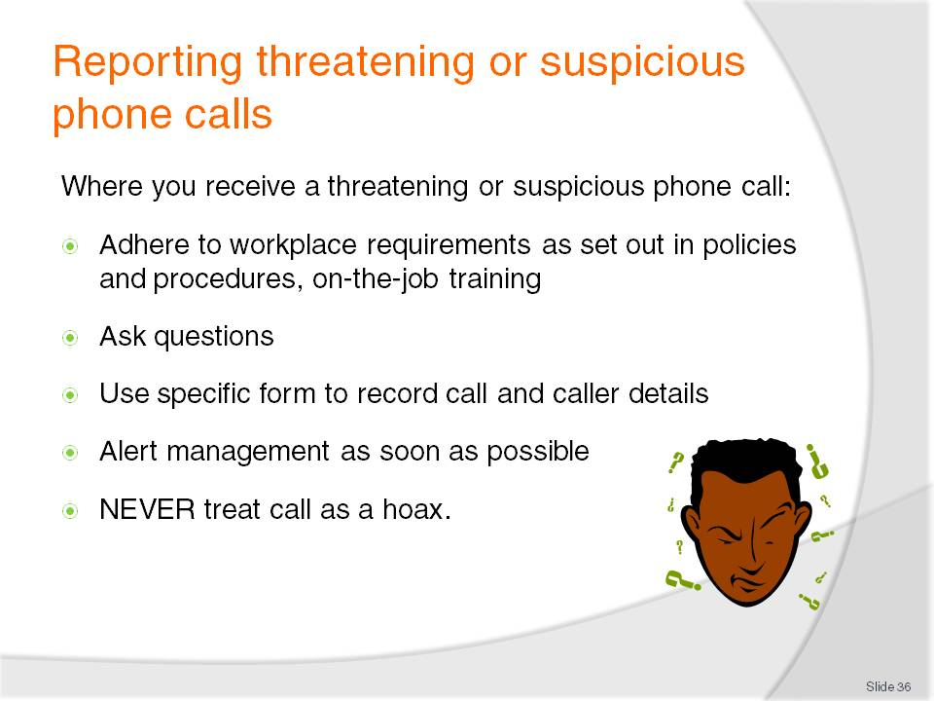
Slide No | Trainer Notes
Trainer informs students they must determine what the workplace protocols are for handling threatening and/or suspicious phone calls and adhere to those at all times.
Trainer identifies suspicious or threatening phone calls as:
Bomb threats
Hold-up threats
Threats to staff members
Threats of retribution
Threats to damage property
Nuisance or prank callers.
Trainer advises students if they receive a threatening or suspicious phone call they should:
Follow workplace procedures for dealing with threatening or suspicious calls. There is a need to become familiar with those procedures now. Do not wait to receive a threatening call before finding out
Ask questions. It is important to ask questions of the caller when they make their threat [see next slide for examples]
Use the dedicated form to record such calls. Know where the form is kept to record details of threatening calls and use it because it contains prompts about what questions to ask and about what information about the call and/or caller to record
Alert management or the identified chain of command immediately without alarming customers or causing panic
Never treat any threatening or suspicious call as a hoax. Every call must be considered genuine. This means always reporting the call to your Supervisor immediately and undertaking planned responses (which may include evacuation, notifying the authorities, following the directions for the business as set out in the Emergency Management Plan for the business).

Slide
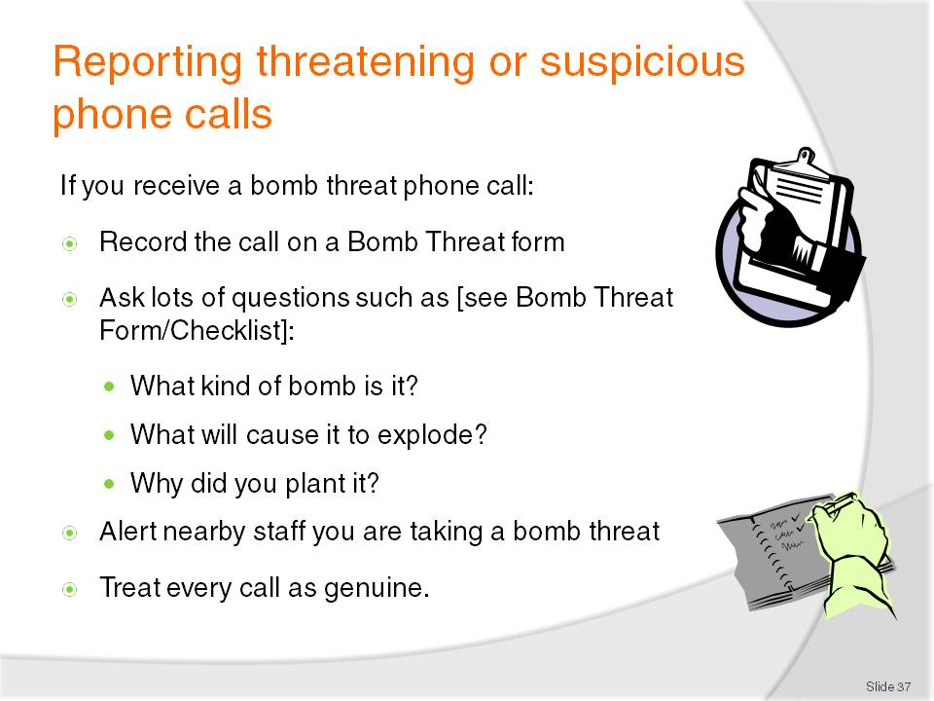
Slide No | Trainer Notes
Trainer informs students they should use a dedicated form to capture information about a bomb threat call stressing they should:
Ask the caller lots of questions such as:
- “Who are you?”
- “What does the bomb look like?”
- “When is the bomb due to explode?”
- “Why did you plant the bomb?”
- “How can we defuse it?”
Alert nearby staff you are receiving a bomb threat by waving arms, writing a note, activating a silent alarm
Treat the call as genuine every time, regardless of personal thoughts about the call.
Class Activity – Discussion of Bomb Threat Procedures and Checklist
Trainer downloads document from http://www.dhs.gov/xlibrary/assets/ocso-bomb_threat_samepage-brochure.pdf and:
Presents copy to students
Discusses implementation of the procedures
Demonstrates use of Checklist.

Slide
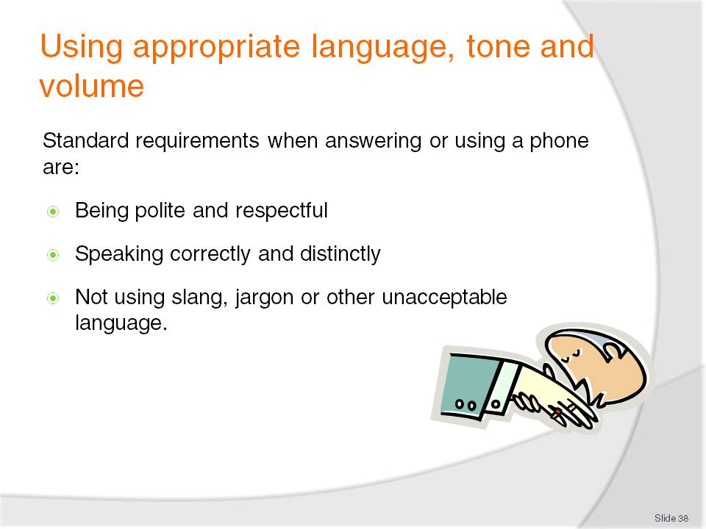
Slide No | Trainer Notes
Trainer informs students standard requirements when answering or using the telephone are:
Being polite and respectful to all callers, regardless of:
- Their age, gender or nationality
- Other work pressures you are under
- Time of day. Treat the last call of the day with the same care and attention as the first call of the day
Speaking correctly and distinctly – not mumbling, speaking directly into the phone, eliminating background noises that can hinder communication or cause a barrier to communication
Not using slang, jargon or other unacceptable language. This includes not using trade or industry terms that the customer may not be familiar with or may not know the true meaning of.

Slide
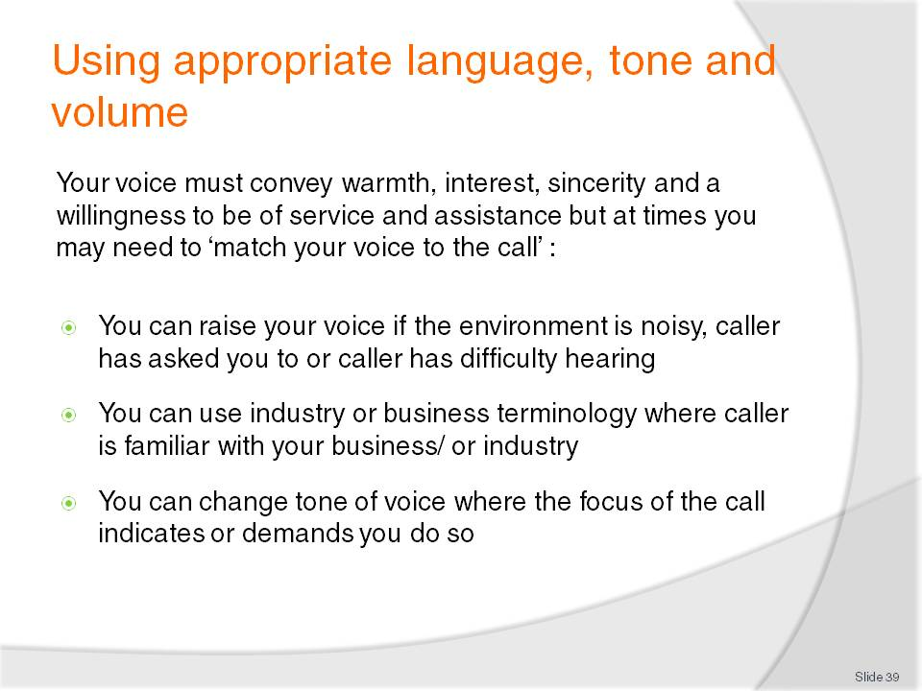
Slide No | Trainer Notes
Trainer informs students their standard voice on the telephone must be warm and friendly but they should strive to use their discretion or common sense to ensure their voice is matched to the individual call and its needs and the needs of the individual caller.
Trainer identifies for students situations where a departure from ‘standard’ language, tone and volume is appropriate:
There may be instances when you need to raise your voice. The caller may be in a noisy environment, they may have a hearing difficulty, or they may have asked you to ‘speak up’
There may be times when the language you use needs to be considered and adjusted as required. These may be instances such as:
- Dealing with an industry person who is familiar with trade terminology and with whom you can use industry terms quite safely knowing they will understand what is being said
- Talking to someone who is a regular patron and is familiar with your business or your operations. This means you can make reference to various facilities, rooms, services in the business knowing they will understand what you are talking about
- Talking with a very young or very old person and meeting their expectations in terms of language or words used.
There may also be times where you believe a change in your tone is called for. Perhaps when dealing with someone who is trying to reach a decision and requires lots of information, or someone who is being inappropriately suggestive on the phone.

Slide
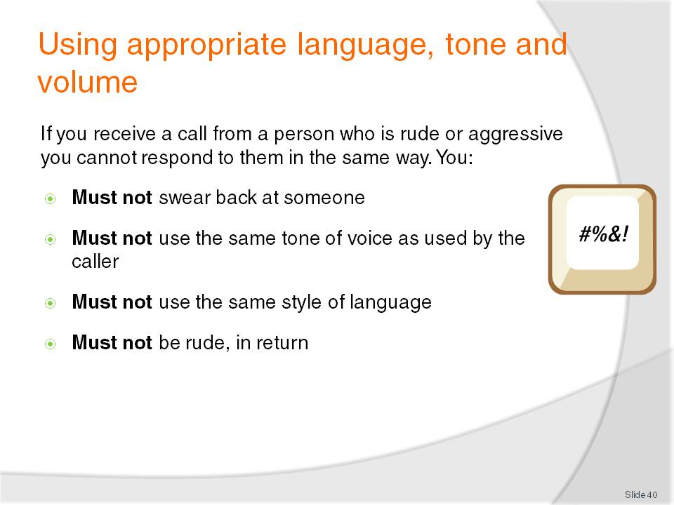
Slide No | Trainer Notes
Trainer informs students they may answer a call from a rude or aggressive caller and if this occurs they:
Must not swear back at someone who swore at you in the first place
Must not use the same tone of voice as used by the caller when they are obviously annoyed
Must not use the same style of language. Your responses and the language you use must always remain professional and always reflect the image
Must not be rude, in return. While at work there is never any justification for being rude to any caller or customer regardless of the circumstances.

Slide
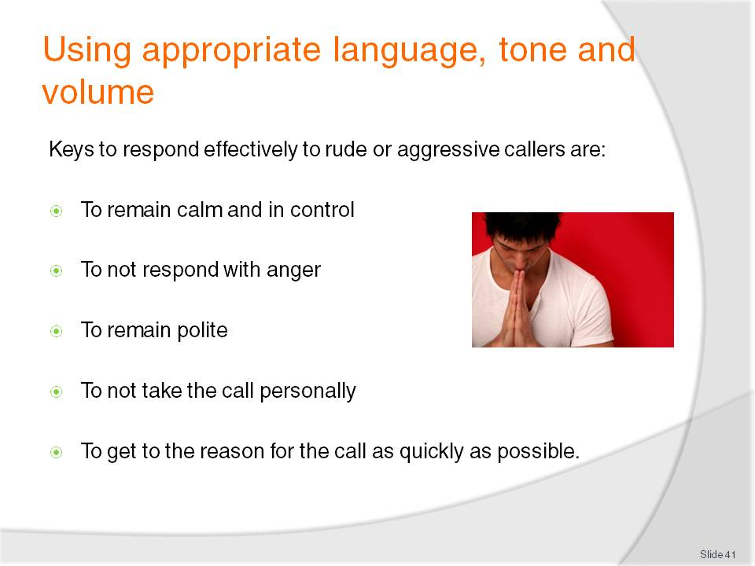
Slide No | Trainer Notes
Trainer provides students with techniques to deal effectively with rude or aggressive calls:
To remain calm and in control. This may be achieved by:
- Taking a deep breath mentally
- Recognising the call for what it is. It is an unusual call (that is, accepting most calls are not like this): do not allow this call to spoil your day or ruin your reputation
- Seeing the call as a challenge rather than a problem/issue and doing your best to meet the challenge the call presents
To not respond with anger regardless of how much you may feel like it, feel it is appropriate, or are being provoked. You must respond calmly in order to try to calm the other person down
To remain polite in your responses – using ‘Sir’, ‘Madam’, please’ and ‘thank you’. The theory being the more polite you are, the more you encourage a similar response from the caller
To not take the call personally. Try to remember the caller is not upset with you personally; instead they are angry at someone or something else. You just happened to be the one who picked up the phone so never believe their anger, rudeness, sarcasm, tone of voice is directed at you
To get to the reason for the call as quickly as possible by redirecting their statements (criticisms, nastiness) back to the real point of the call (that is, what they want to discuss). You need to cut through their initial anger as quickly as possible and start addressing their real problem:
- “Yes, Sir I can tell you are upset and I apologise. Will you allow me to transfer you to Mr Smith, our manager, so he can talk to you? He has the authority to deal with this kind of issue”

Slide
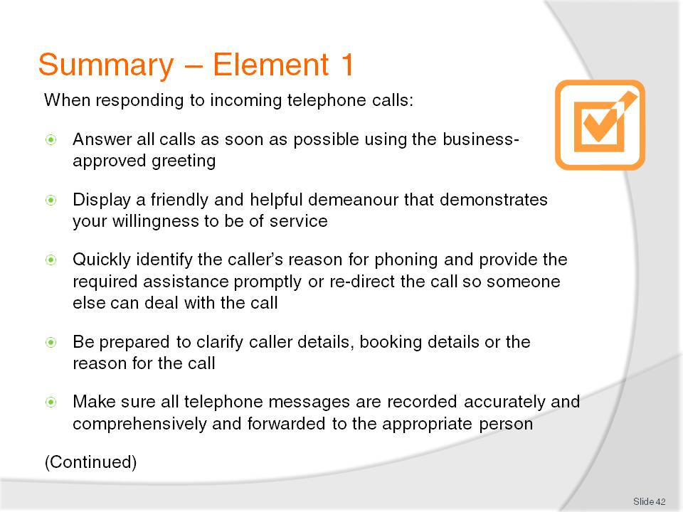
Slide No | Trainer Notes
 | Trainer provides a recap of the Element asking questions to check student understanding and responding to questions from students, as required.

Slide
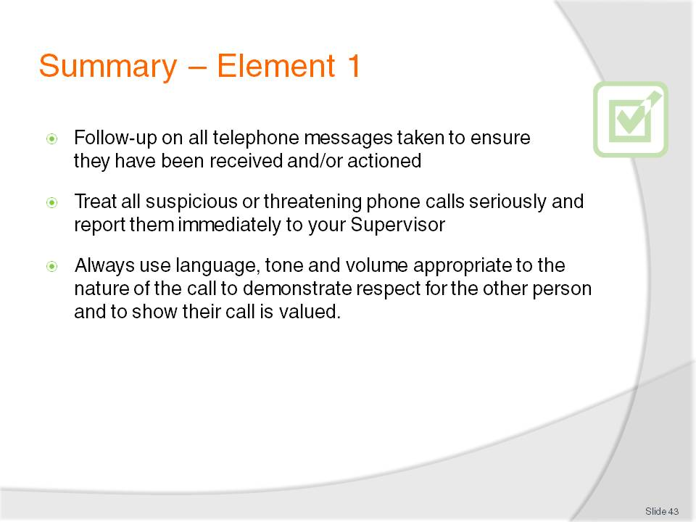
Slide No | Trainer Notes
 | Trainer provides a recap of the Element asking questions to check student understanding and responding to questions from students, as required.

Slide
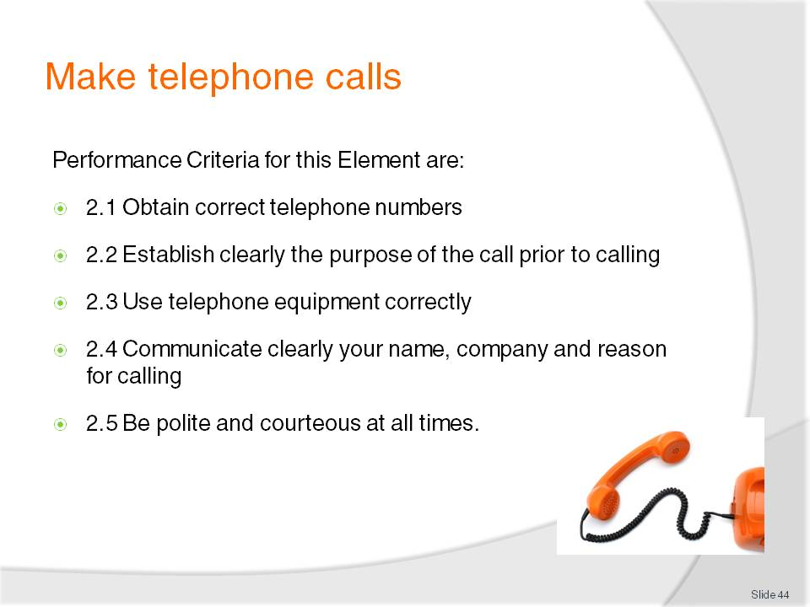
Slide No | Trainer Notes
 | Trainer identifies for students the Performance Criteria for this Element, as listed on the slide.

Slide
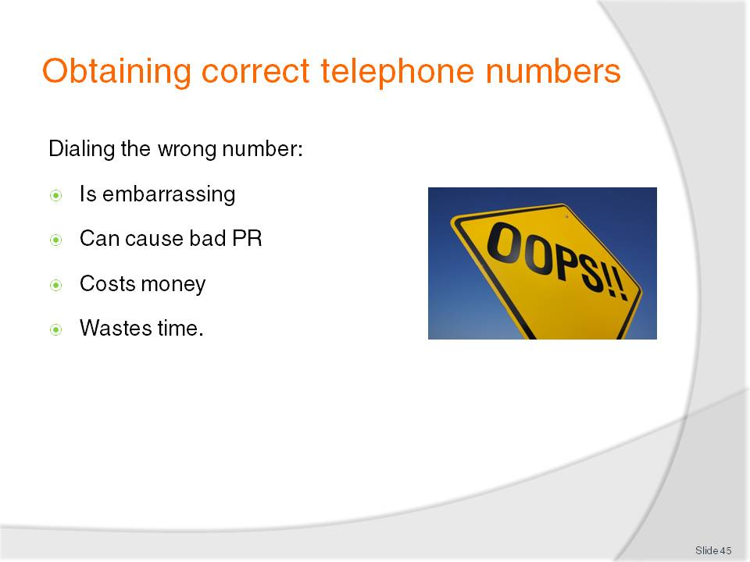
Slide No | Trainer Notes
Trainer explains to students there can be numerous reasons to make an outgoing phone call from work.
Class Activity – General discussion
Trainer asks students for examples of reasons why they may have to make an outgoing telephone call from a workplace and writes them on board.
Possible reasons/answers may include:
Confirm a reservation with a booking holder
Place an order with a supplier or lodge a booking with a provider
Follow up a customer enquiry by phoning the customer back
Follow up a customer complaint
Make an enquiry or find information
Promote a service, facility or product
Pass on messages.
Trainer stresses it is important for students to obtain the correct telephone number before dialling as not doing so can:
Be embarrassing – to you especially when you do so in front of a customer who is waiting on the outcome of the call
Lead to bad public relations – for the business when the other party knows who made the call
Cost money – every phone call costs the business money
Waste time – in redialling; in finding the correct number – it is often, therefore, quicker, to find the correct number in the first place.

Slide
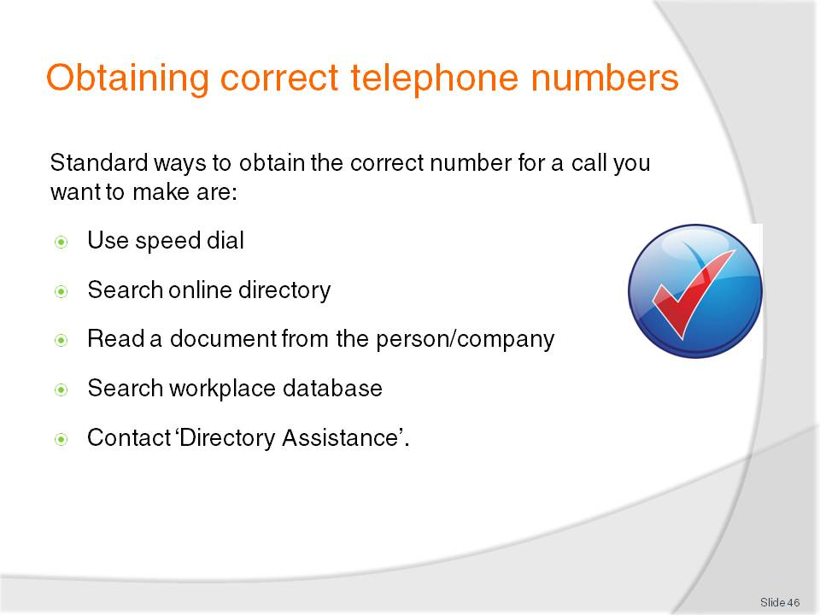
Slide No | Trainer Notes
Trainer advises students the standard ways of determining the ‘correct’ telephone number for a call they want to make are:
Use speed dial, making sure all numbers in the speed-dial facilities are updated as required when organisations change their numbers
Search online directory using the Internet facilities at your workplace. It is a good idea to Bookmark commonly used Telephone Directory information sites from different countries or areas
Read a document from the person or company. A letter from a customer may contain their phone number. Most documents from suppliers or providers will feature their telephone number and there will often be a Free call number
Contact ‘Directory Assistance’ and ask them for the required number.

Slide
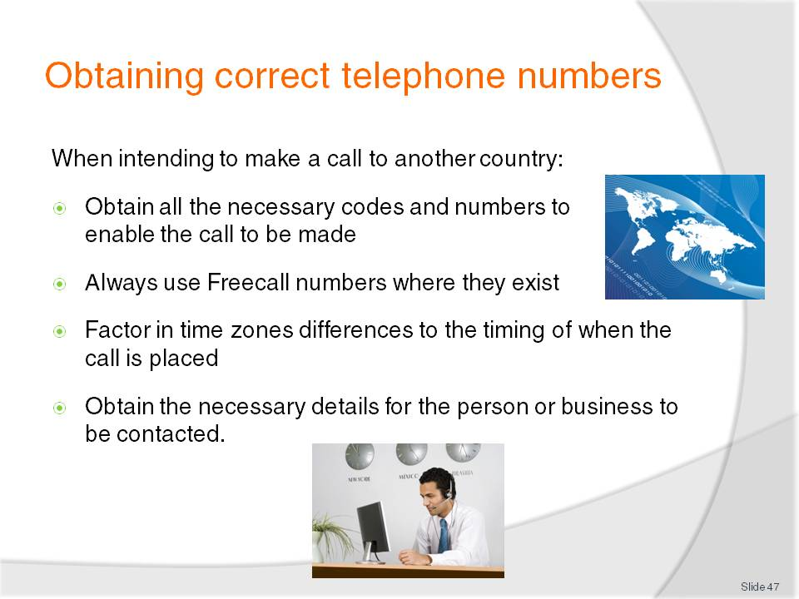
Slide No | Trainer Notes
Trainer advises students that when they search for an international number they must make sure they:
Obtain all the necessary codes and numbers to enable the call to be made:
- Country code
- Area code
- Number for the business/person
- Free call number
Always use Free call numbers where they exist to save money for the workplace
Factor in time zones differences to the timing of when the call is placed to avoid placing a call at an inappropriate time where this is relevant
Obtain additional call details as necessary, such as name of person or department to be spoken to and their title position.
Class Activity – Research exercise
Trainer provides students with the names of five organisations in different countries and asks them:
To find out the full telephone number including Country, Area and other codes necessary to make the call
To identify the local time each call would need to be placed to contact the other country at 10:00AM their time.
Slide
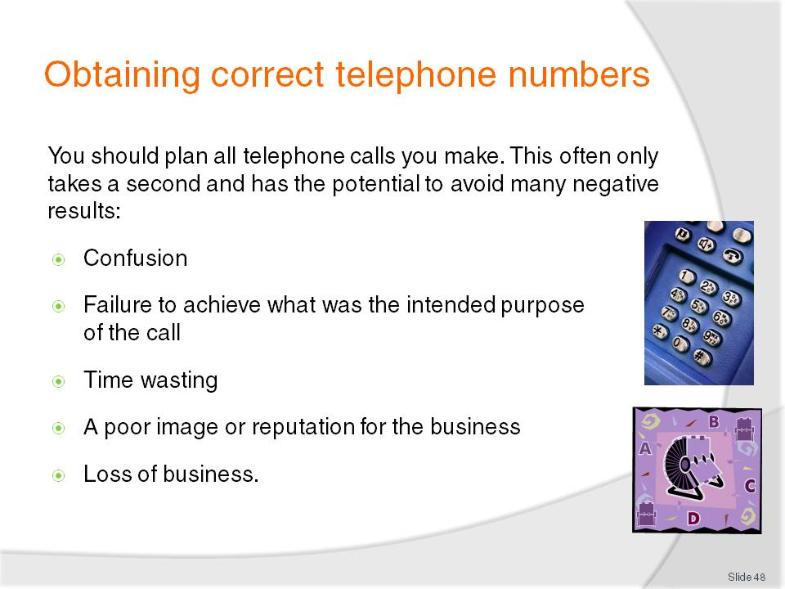
Slide No | Trainer Notes
Trainer identifies to students a common fault people make when making a phone call is to dial the number and then try to work out what it is they are going to say which often results in:
Confusion for all parties. It is much more difficult for the other party to understand what you are saying and what you want if you do not know
Failure to achieve what was the intended purpose of the call. Failing to plan increases the chances of you not securing information you wanted, not passing on necessary information etc.
Time wasting. A call that fails to achieve its intended outcomes often has to be repeated. The ‘waste of time’ refers to a waste of time for the business and for the other party (customer, supplier, provider)
A poor image or reputation for the business which may result in others not referring potential customers to us. They may also tell others about our unprofessional attitude and approach
Loss of business as the other party loses confidence in the organisation.

Slide
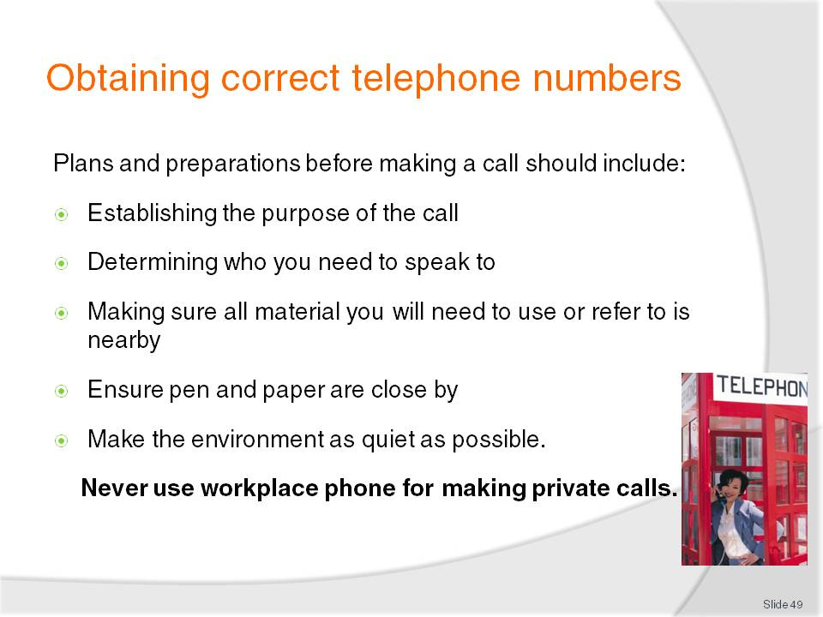
Slide No | Trainer Notes
Trainer explains to students in order to optimise the chances of making an effective telephone call, before making the call they need to:
Establish the purpose of the call. Why are you phoning this person or organisation? What is it you want to achieve? Do you want to obtain information or provide it? Exactly what information needs to be captured or given?
Determine who you need to speak to. If you do not know a person’s name you should at least determine which department or area you need to make contact with
Have all relevant information at your fingertips depending on the reason for the call. This could include:
- Previous correspondence with that person or organisation
- Lists or brochures relating to products or services, including price lists, special deals/offers, product information sheets, menus, flight/tour schedules
- Details on the important points of the discussion you want to have with the other person such as the details of an offer, the parameters of any negotiation you intend entering into, process details, dates, times, numbers/statistics. Make sure you only ever negotiate with people within your specified scope of authority and be prepared to pass the call on to a Supervisor or other appropriate person when these limits are reached and/or there is need for the negotiation to go beyond these boundaries
Ensure pen and paper are close by to record any information given by the other party
Make the environment as quiet as possible – close doors, turn down or turn off music etc.
Trainer states to students it is never acceptable to use the work phone to receive or make private phone calls, highlighting this is unacceptable in all workplaces as it costs the employer time and money.

Slide
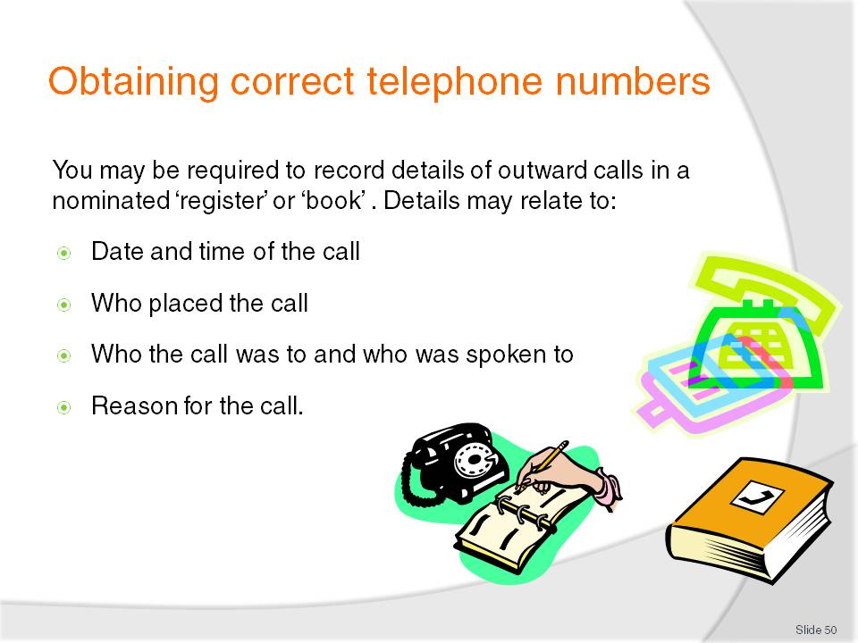
Slide No | Trainer Notes
Trainer advises students that some organisations maintain a ‘Calls Out’ book/’Outward Calls’ register requiring them to log all calls placed detailing all or some of the following:
Date and time of the call. The duration of the call may be required where the call is international or out-of-area
Who placed the call – by name or initials
Who the call was to or who was spoken to, meaning the name of a person, company or organisation has to be entered
Reason for the call – ‘Confirm booking’, ‘Cold call’, ‘Return call’ etc.
Class Activity – Outwards Calls Register
Trainer obtains a sample Outwards Calls Register (or book, or similar – the one used by the Training Institute may be suitable) and:
Shows it to students
Explains each heading
Illustrates the use of the book/register by reference to entries made.

Slide
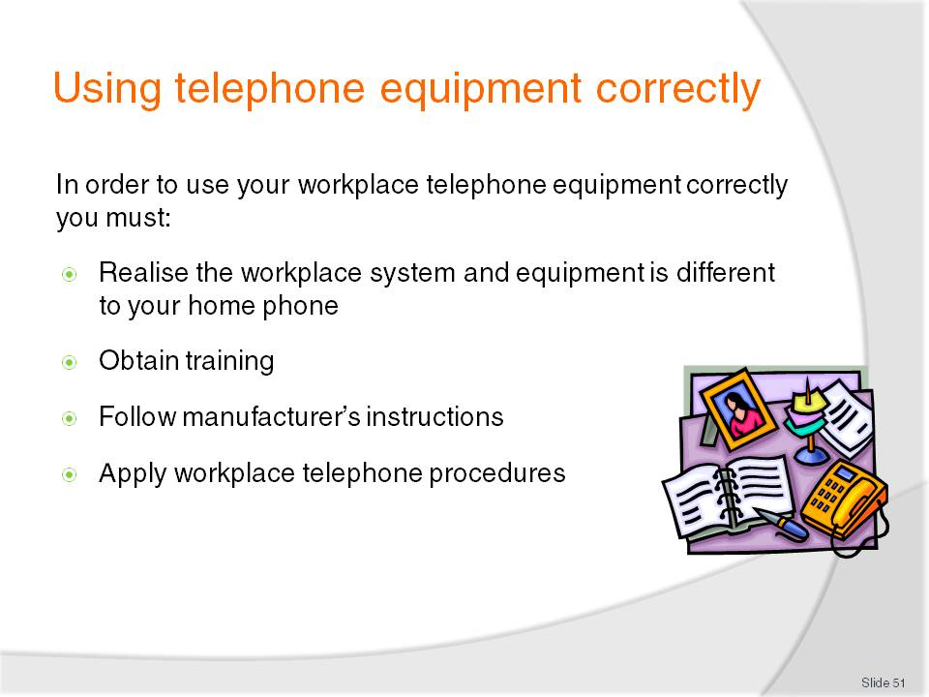
Slide No | Trainer Notes
Trainer notes to students the telephone at work is likely to be different to what they use at home. He/she explains that, while there are certainly going to be similarities between their home phone and their work phone, the work phone is generally part of a larger system, has many more facilities, and commonly requires them to undertake some form of training to become fully competent in its use.
Trainer states to students their ability to operate the system or equipment properly will depend on:
Obtaining training which can include:
- Attending a course conducted by the supplier or manufacturer of the system. This is only an option for those who live in or near a capital city in most cases. In limited cases, the supplier may also make an on-site visit to train staff. This usually only applies where a new system has been installed and is not generally available to individual staff as they join an organisation as a new staff member
- Reading the manual or instructions and practicing with the system as you read to assist in becoming familiar with how it operates
- Receiving on-the-job training. This is the most common and features an experienced operator explaining the system to you. It involves you watching and listening to them and then you gradually take over progressively more complex tasks as you learn the system and gain confidence and competency
Attending in-house training courses. Some establishments will offer training in their training room in relation to what the phone system can do, and how to use it.
Slide
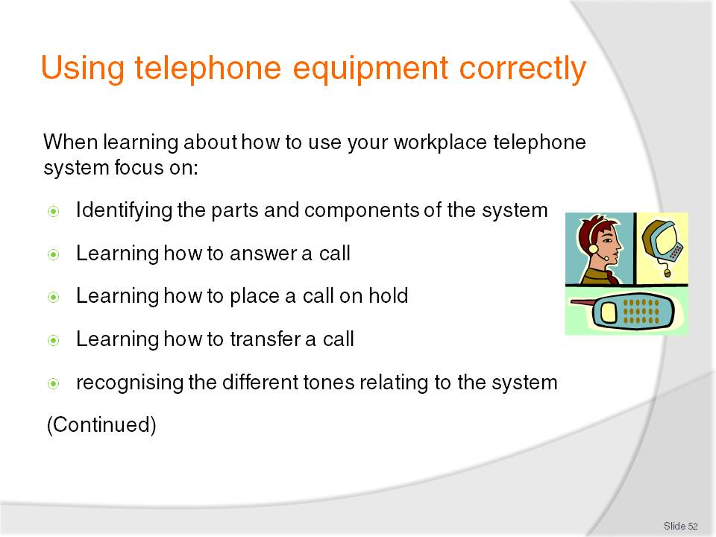
Slide No | Trainer Notes
Trainer explains to students they will only need to learn how to use the telephone system and equipment as it exists within their workplace suggesting their effort should be focused on:
Identifying the parts and components of the system – buttons, lights, displays, add-on and integrated components
Learning how to answer a call – both an internal call and an external - as well as learning how to identify the difference between these calls
Learning how to place a call on hold
Learning how to transfer a call
Recognising the different tones relating to the system. Most systems produce a different tone to distinguish between internal incoming calls and external incoming calls.

Slide
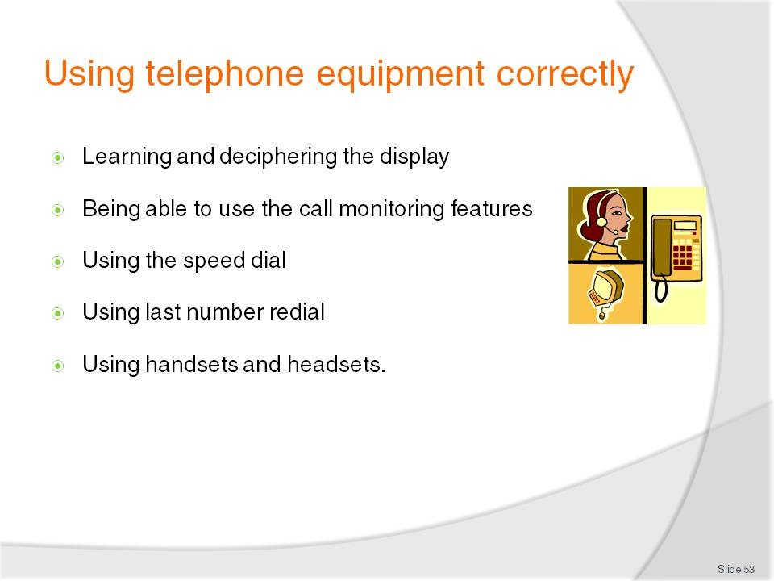
Slide No | Trainer Notes
Trainer continues to identify for students the aspects of a workplace telephone system and equipment they should focus on learning:
Learning and deciphering the display on the handset/console
Being able to use the call monitoring features as specific to individual systems, makes and models
Using the speed dial which will involve finding out about the numbers and associated contacts entered into the speed dial facility (this may be a paper-based list or a system-based display on the handset/console)
Using last number redial
Using handsets and headsets.

Slide
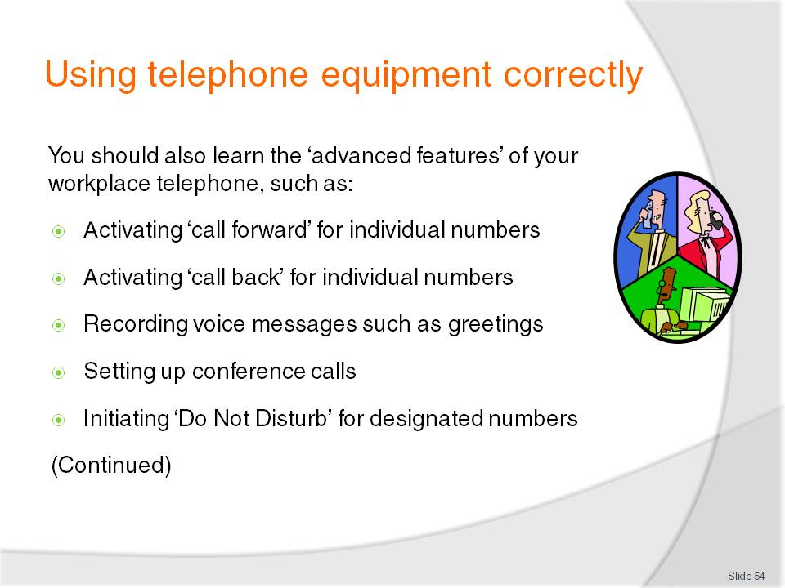
Slide No | Trainer Notes
Trainer highlights to students individual systems vary depending on their size, cost and the needs of the business and learning the advanced features may cover things such as:
Activating ‘call forward’ for individual numbers. This forwards an incoming call to a designated number if the extension does not answer within a given number of rings
Activating ‘call back’ for individual numbers
Recording voice messages such as greetings
Setting up conference calls. This is used by many businesses, especially where they have numerous offices in different countries or locations
Initiating ‘Do Not Disturb’ for designated numbers. This is important in businesses where staff or management are in conferences or meetings and do not want to be interrupted.

Slide
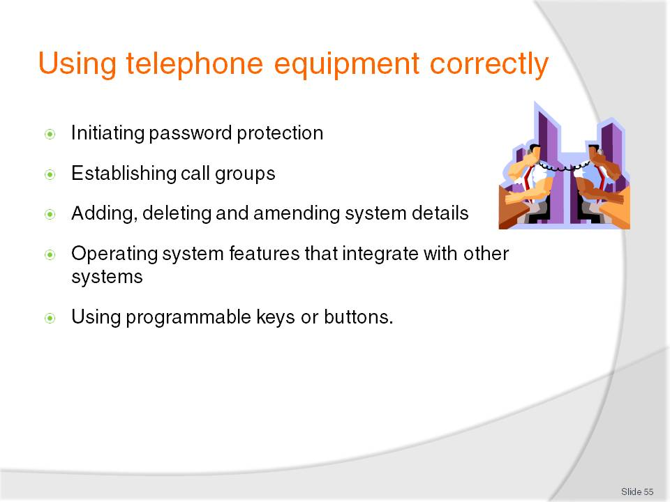
Slide No | Trainer Notes
Trainer continues to identify the ‘advanced features’ of a telephone system that students should strive to learn how to use:
Initiating password protection on designated lines or numbers
Establishing call groups for ease of use
Adding, deleting and amending system details for nominated internal lines or numbers
Operating system features that integrate with other systems such as pagers, call costing, wake and reminder calls, barring or limiting calls to and from designated numbers, messaging etc.
Using programmable keys or buttons as appropriate to the individual workplace.

Slide
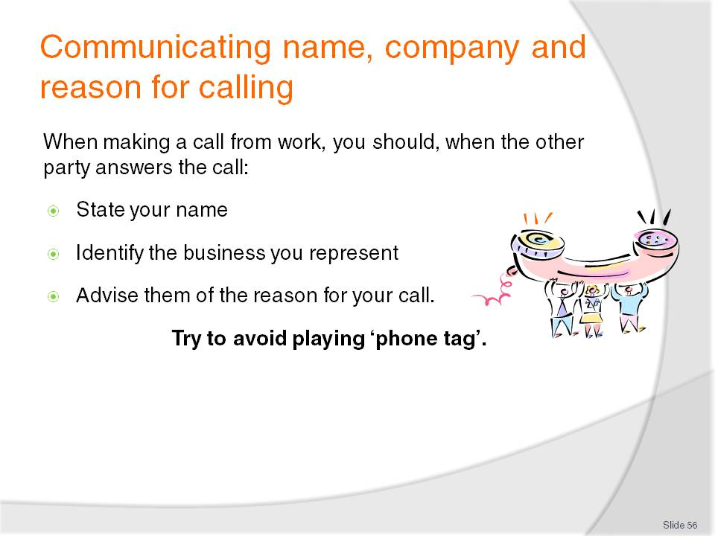
Slide No | Trainer Notes
Trainer explains to students that whenever they make a call from their workplace they should begin the call when it is answered by:
Stating your name clearly: the name may be your full name (that is, first and surname), or just the first name (in accordance with workplace standards)
Identifying the business you represent according to accepted or required format: that is the words ‘proprietary’, ‘company’, ‘limited’ and certain other words are commonly omitted
Advising them of the reason for your call or the person you want to speak with.
Trainer explains to students that ‘phone tag’ is where they ring someone and the person they want is unavailable, so they leave a message or their number. The other person then returns their call and finds the person who left the message is unavailable, so they leave a message. The first caller then phones back … and the cycle continues.
Trainer indicates some organisations and/or individuals prefer not to get caught up in this ‘game of tag’ and will neither leave a message nor give a return number. Their preference may be to keep control of the communication by deciding it is best if they retain the decision about when to make the call and speak to the other person.
Trainer recommends students talk to their Supervisor and see if their employer has any preferences in this regard, stressing most businesses will want a message to be left where:
They have promised to call
They have promised to provide information
The matter is urgent.

Slide
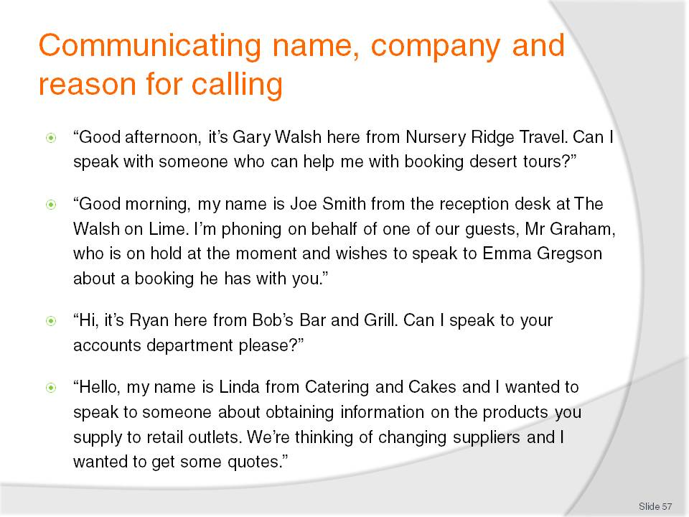
Slide No | Trainer Notes
 | Trainer explains to students that stating their name, the business they represent and their purpose for calling must be done in accordance with enterprise standards.

Slide
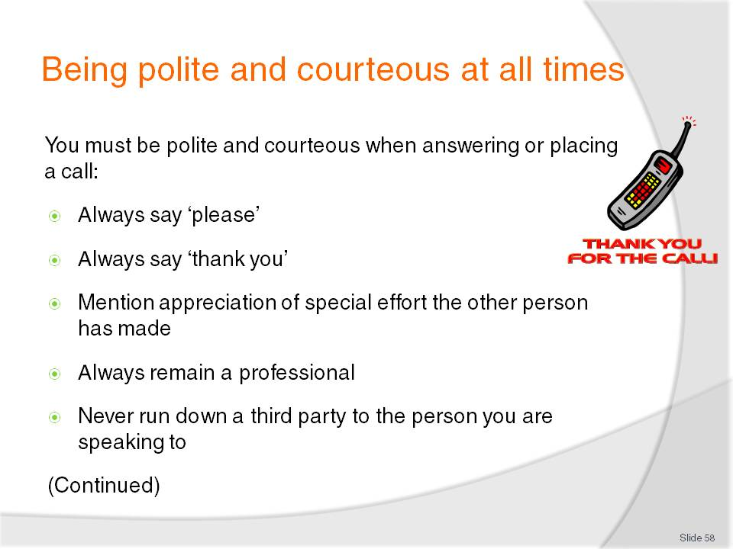
Slide No | Trainer Notes
Trainer states to students that in the same way they are expected to be polite and courteous when taking a telephone call, so too are they expected to be polite and courteous when making a call.
Trainer presents points to note when taking or making a call include:
Always say ‘please’ when asking for something
Always say ‘thank you’ when provided with information or assistance that was required
Make mention of your appreciation of any special effort the other person has made on your behalf such as extra effort in locating a certain person, finding required information, making a sensible suggestion that may not have solved your problem but has helped it along the way
Always remain a professional even when the other party may be rude, unhelpful, or extremely unprofessional themselves
Never run down a third party to the person you are speaking to. For example, don’t mention to the person in Accounts the person on the switchboard was slow, or unhelpful.

Slide
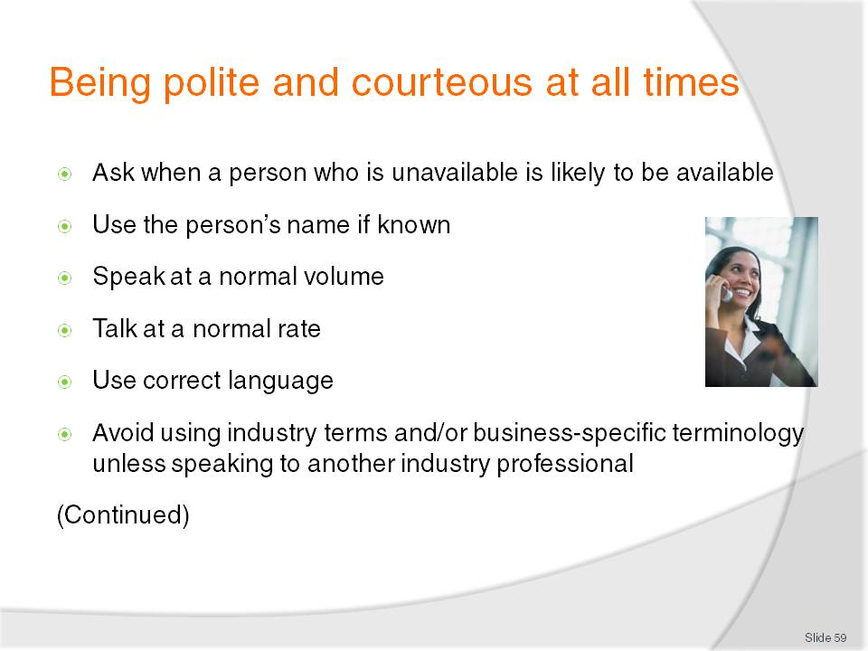
Slide No | Trainer Notes
Trainer continues to present points to note when taking or making a call:
Ask when a person who is unavailable is likely to be available or ask them when the best time to call is
Use the person’s name if known or use ‘Sir’ or ‘Madam’ according to business protocols when talking to a caller
Speak at a normal volume – don’t whisper and never shout
Talk at a normal rate – don’t rush the call
Use correct language – don’t swear, never use slang expressions, don’t joke (many complaints have arisen as a result of a staff member making what they thought was a funny comment but which the other person didn’t find at all humorous); don’t make racist, sexist or ageist comments
Avoid using industry terms and/or business-specific terminology unless speaking to another industry professional – this can confuse people outside the organisation and make them feel they are being excluded from the conversation.

Slide
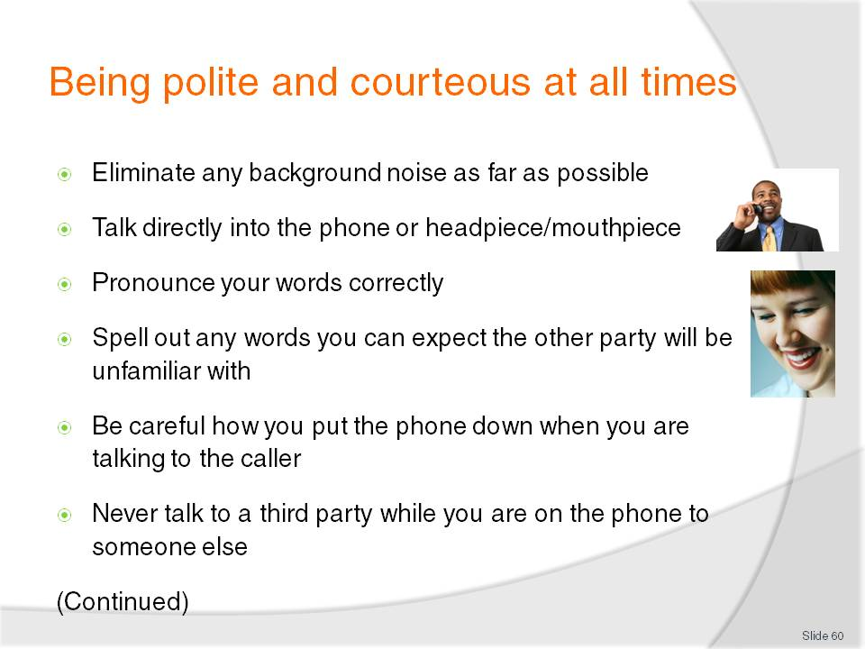
Slide No | Trainer Notes
Trainer continues to present points to note when taking or making a call:
Eliminate any background noise as far as possible – turn off radios/music; close doors and windows to reduce noise from other areas
Talk directly into the phone or headpiece/mouthpiece to optimise likelihood of other person understanding
Pronounce your words correctly to facilitate correct hearing
Spell out any words or terms you can realistically expect the other party will be unfamiliar with
Be careful how you put the phone down when you are talking to the caller. Put it down gently to avoid noise to the other party
Never talk to a third party while you are on the phone to someone else – it is rude, unprofessional and distracting.

Slide
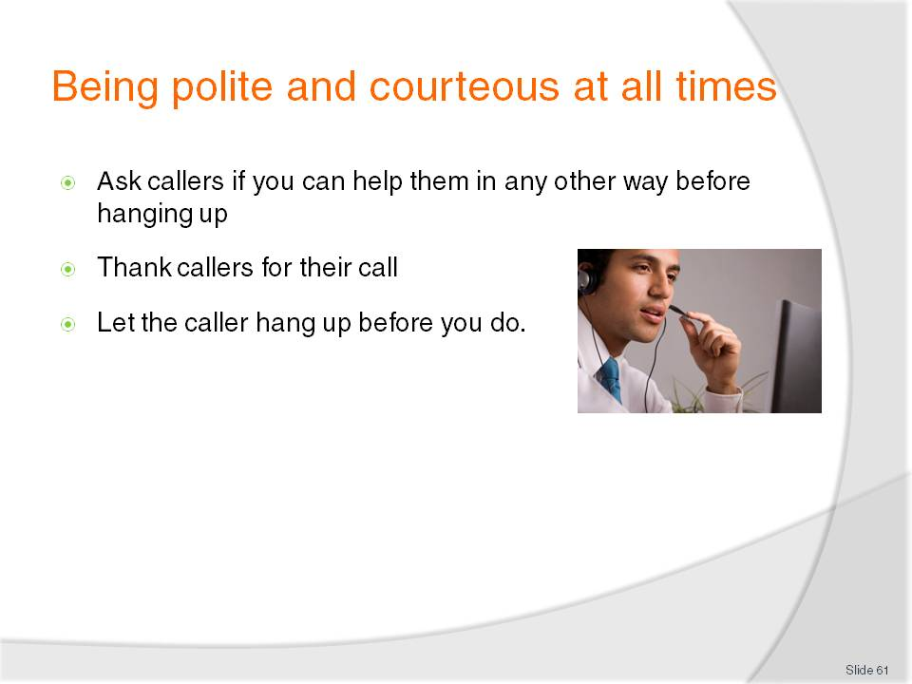
Slide No | Trainer Notes
Trainer continues to present points to note when taking or making a call:
Ask callers if you can help them in any other way before hanging up. This applies to ending incoming calls
Thank callers for their call, where appropriate. Once again, this only applies to incoming calls
Let the caller hang up before you do just in case they think of a last-minute statement they want to make, or question they want to ask.

Slide
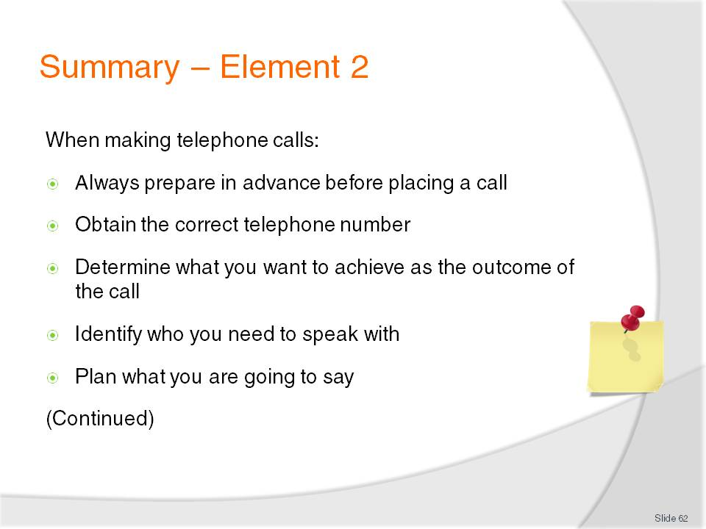
Slide No | Trainer Notes
 | Trainer provides a recap of the Element asking questions to check student understanding and responding to questions from students, as required.

Slide
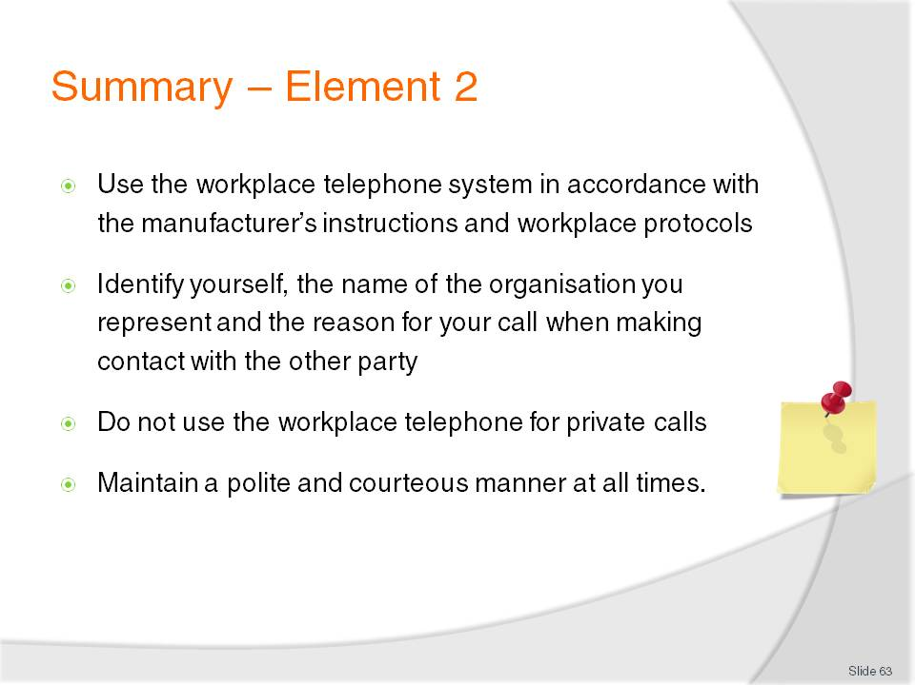
Slide No | Trainer Notes
Trainer provides a recap of the Element asking questions to check student understanding and responding to questions from students, as required.
Trainer thanks students for their attention and encourages them to apply course content in their workplace activities.

Recommended training equipment
Telephone system including handset, headset and base station for making, receiving and transferring calls, placing calls on hold and a range of ancillary services such as ‘Follow Me’, ‘Call Forward’
Local, regional, national and international telephone books
List of international dialling numbers
Chart of telephone charge rates – venue-based samples
Telephone message pads
Intercom/public address system
Samples of enterprise standards, policies and procedures for using the telephone.

Instructions for Trainers for using
PowerPoint – Presenter View
Connect your laptop or computer to your projector equipment as per manufacturers’ instructions.
In PowerPoint, on the Slide Show menu, click Set up Show.
Under Multiple monitors, select the Show Presenter View check box.
In the Display slide show on list, click the monitor you want the slide show presentation to appear on.
Source: http://office.microsoft.com
Note:
In Presenter View:
You see your notes and have full control of the presentation
Your trainees only see the slide projected on to the screen
More Information
You can obtain more information on how to use PowerPoint from the Microsoft Online Help Centre, available at: http://office.microsoft.com/training/training.aspx?AssetID=RC011298761033
Note Regarding Currency of URLs
Please note that where references have been made to URLs in these training resources trainers will need to verify that the resource or document referred to is still current on the internet. Trainers should endeavour, where possible, to source similar alternative examples of material where it is found that either the website or the document in question is no longer available online.

Appendix – ASEAN acronyms
AADCP | ASEAN – Australia Development Cooperation Program.
ACCSTP | ASEAN Common Competency Standards for Tourism Professionals.
AEC | ASEAN Economic Community.
AMS | ASEAN Member States.
ASEAN | Association of Southeast Asian Nations.
ASEC | ASEAN Secretariat.
ATM | ASEAN Tourism Ministers.
ATPMC | ASEAN Tourism Professionals Monitoring Committee.
ATPRS | ASEAN Tourism Professional Registration System.
ATFTMD | ASEAN Task Force on Tourism Manpower Development.
CATC | Common ASEAN Tourism Curriculum.
MRA | Mutual Recognition Arrangement.
MTCO | Mekong Tourism Coordinating office.
NTO | National Tourism Organisation.
NTPB | National Tourism Professional Board.
RQFSRS | Regional Qualifications Framework and Skills Recognition System.
TPCB | Tourism Professional Certification Board.







